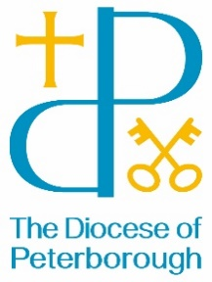
BISHOP’S MANAGEMENT GROUP LETTER
17 January 2024

Dear Friends
It’s a joy this month to be able to read that three of our churches have gained their Silver Eco Church award – this comes as a result of much effort by many people so congratulations!
It made me reflect that as we make our way into 2024 we find ourselves in the usual mix of Church seasons moving from the Glory of Epiphany to the Sunday before Lent, where as always we will find ourselves at the Transfiguration, then down the mountain and into Lent.
Alongside which we travel through the seasons of the natural world moving from Winter into Spring with all the signs of God at work in both.
Those churches who have gained their Silver Eco church award will have been working on the connections between faith and the environment, in line with the fifth mark of mission “To strive to safeguard the integrity of creation and sustain and renew the life of the earth.”
Our faith, in both the natural seasons and the seasons of faith, help us not only in this mark of mission but in others too, to proclaim the Glory of God as the Heavens do (Psalm 19) and to challenge unjust structures which so often see the poorest communities suffering most.
This is a challenge, to us individually and corporately, to be the people of God in the place where we are. Speaking through word and action the love of God our creator, that others may see something of the glory of God revealed in the Christ of Christmas and Epiphany and travel with us down the mountain and through the valley to the cross and beyond to Easter Sunday.
In 2024, as the Diocese of Peterborough, let us seek to live out our faith in ways that connect with every place and every generation today.

The Venerable Alison SW Booker

