**Baptism and Admission to**

**Holy Communion**

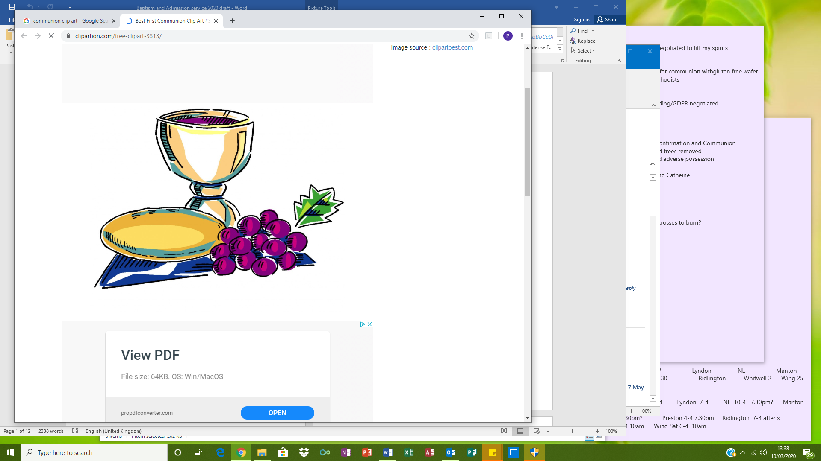

St John the Baptist, North Luffenham

Monday 20thth May 2024

Welcome to this Baptism and Admission to Holy Communion!

People formally join the Christian Church through baptism. Some people are baptised as babies, when parents and godparents declare their own faith in God and their intention to bring the child up within the church family. Other people choose to be baptised when they are old enough to make this public declaration of their Christian faith. Baptism is an important beginning, but being a Christian is a journey of a lifetime.

Christian people seek to follow Jesus Christ, so we read about God in the Bible, spend time with God in prayer and are fed by God at our shared family meal, Holy Communion. Young people can be admitted to receiving Communion, on occasions like today, and later we hope they will publicly express an adult commitment to living throughout their lives as Christians by coming to Confirmation.

You are most welcome here as we celebrate the next steps these young people are taking on their journey of faith within the Christian community.

Today we are here to support Sienna Adams and Arlo McKinlay as they are baptised, and Sienna Adams, Catherine Connolly, Christian Graham, Felicity Harrison, Arlo McKinlay and Oscar Oliver as they are all admitted to receiving Holy Communion.

Please join in words in the hymns and words **bold type**.

***Bold + italics*** indicates responses for the candidates alone.

The young people and several adults are leading parts of the service:

Mrs Wilce, Head Teacher of St Mary and St John School, North Luffenham Rev’d Pippa Madgwick, Rector of North Luffenham

Mr Peter Cantley, Diocesan Director of Education

**Preparation**

*Rev’d Pippa welcomes everyone*

Peace be with you

**and also with you.**

*Mrs Wilce leads the candle prayer*

**Loving Lord, as we light this candle, we ask you to guide us through our lives. May the fruit of the Spirit shine in all that we do. We pray for our church, our community, family and friends. We ask that your light will shine brightly in us, so we can pass your light on to others. Amen.**

**Song 18: Colours of Day**

*Mrs Wilce lead a time of confession*

We have not always trusted in God our Father

Lord have mercy **Lord have mercy**

We have not always followed Jesus our Saviour

Christ have mercy **Christ have mercy**

We have not always trusted in the Spirit our guide

Lord have mercy **Lord have mercy**

*Rev’d Pippa prays*

May the God of love bring you back to himself, forgive your sins and assure you of eternal life in Jesus Christ our Lord. **Amen.**

*The Collect*

Heavenly Father, by the power of your Holy Spirit

you give your faithful people new life in the water of baptism.

Guide and strengthen us by the same Spirit,

that we who are born again may serve you in faith and love,

and grow into the full stature of your Son, Jesus Christ.

**Amen.**

**Liturgy of the Word**

|  |  |
| --- | --- |
| *We listen to words from Matthew 7. 24-27*  Talk:Rev’d Pippa | Image result for bible Clip Art Black and White |

**The Liturgy of Baptism and Admission**

*Rev’d Pippa invites the candidates to stand*

Some of these young people are here today to be baptised;

all are here to be admitted to receiving Holy Communion.

*Rev’d Pippa asks the candidates*

Are you each ready to affirm your faith in Jesus Christ? ***I am*.**

*And asks the candidates for baptism*

Sienna and Arlo, do you wish to be baptised? ***I do.***

*then asks the other candidates for admission to communion*

Cate, Chris, Felicity and Oscar, have you been baptised in the name of the Father and of the Son and of the Holy Spirit? ***I have.***

*Rev’d Pippa addresses the whole congregation*

Faith is the gift of God to his people.

In baptism the Lord is adding to our number those whom he is calling.

People of God, will you welcome these young people

and uphold them in their life in Christ?

**With the help of God, we will.**

*Rev’d Pippa, all the candidates and the families + godparents of those being baptised move to the font.*

*The Decision, addressed to the baptism candidates*

We all wander far from God and lose our way:

Christ comes to find us and welcomes us home.

In baptism we respond to his call.

Therefore I ask:

|  |  |
| --- | --- |
| Do you turn away from sin? ***I do.***  Do you reject evil? ***I do.***  Do you turn to Christ as Saviour? ***I do.***  Do you trust in him as Lord? ***I do.*** | Image result for cross Clip Art Black and White |

*The sign of the cross is made on their foreheads*

Christ claims you for his own. Receive the sign of his cross.

Do not be ashamed of Christ. You are his for ever.

**Stand bravely with him against all the powers of evil,**

**and remain faithful to Christ to the end of your life.**

|  |  |
| --- | --- |
| May almighty God deliver you from the powers of darkness,  and lead you in the light and obedience of Christ. **Amen.** |  |

*Prayer over the Water,*

Praise God who made heaven and earth,

**who keeps his promise for ever.**

Let us give thanks to the Lord our God.

**It is right to give thanks and praise.**

We praise you, loving Father, for the gift of your Son Jesus. He was baptised in the River Jordan, where your Spirit came upon him and revealed him as the Son you love. He sent his followers to baptise all who turn to him. Now, Father, we ask you to bless this water, that those who are baptised in it may be cleansed in the water of life, and, filled with your Spirit, may know that they are loved as your children, safe in Christ for ever. **Amen.**

*Profession of Faith, said by all in church*

Let us affirm, together with these who are being baptised, our common faith in Jesus Christ:

**We believe in God the Father,**

**from whom every family in heaven and on earth is named.**

**We believe in God the Son,**

**who lives in our hearts by faith and fills us with his love**

**We believe in God the Holy Spirit,**

**who strengthens us with power from on high.**

**We believe in one God, Father, Son & Holy Spirit.**

|  |  |
| --- | --- |
| *Baptism*  *Water is poured onto each candidate three times:* | http://cliparting.com/wp-content/uploads/2016/09/Water-waves-clip-art.png |

*N*, I baptise you

in the name of the Father, and of the Son, and of the Holy Spirit. **Amen.**

May God, who has received you by baptism into his Church, pour upon you the riches of his grace, that within the company of Christ’s pilgrim people you may daily be renewed by his anointing Spirit, and come to the inheritance of the saints in glory. **Amen.**

*The candidates for admission to Holy Communion may make a sign of the cross on their forehead with the water, as a reminder of their own baptism.*

Almighty God, we thank you for all who have been baptised today.

Keep us all faithful to our baptism, and so make us ready for that day

when the whole creation shall be made perfect in your Son,

our Saviour Jesus Christ. **Amen.**

**Song 75: Lord the light of your love**

*during which the candidates return to their seats.*

*Prayers led by the candidates*

*Admission to Holy Communion*

*The candidates stand facing the congregation*

*Rev’d Pippa says*

These young people worship God each week at school or in this church and want to take a new step in their journey of faith and receive the sacrament of Holy Communion. We pray their journey will continue and trust they will later affirm their faith in Confirmation.

*Then she addresses first the candidates*   
You love God, follow Jesus, and want to live the Christian life.  
Do you each wish to receive Holy Communion?  
**Yes, I do.**

*and then the congregation*

Parents, godparents and members of this community, you share the responsibility of encouraging them in their worship, and of supporting them by your friendship, your example and your prayers.   
Will you help them to grow in faith and love?

**We will.**

*Rev’d Pippa says*

N, today I admit you to receive the sacrament of Holy Communion - the body and blood of Christ.

*Mrs Wilce gives a certificate to each candidate*

*Rev’d Pippa introduces the Peace*

The peace of the Lord be always with you

**and also with you.**

Let us offer one another a sign of peace. *All may exchange a sign of peace*

**Liturgy of the Eucharist**

*at which Rev’d Pippa presides, assisted by some candidates*

The Lord is here.  
**His Spirit is with us**

Lift up your hearts.  
**We lift them to the Lord.**

Let us give thanks to the Lord our God  
**It is right to give thanks and praise.**

**Pupil’s Question: Why is it right to give thanks and praise?**

**Pupil’s Answer: Listen, and we will hear.**

Lord of all life, you created the universe,

where all living things reflect your glory.

You give us this great and beautiful earth, to discover and to cherish.

You give us sun and moon and star-lit sky, everything that gives us light,

light for our eyes, our hearts, our minds.

You made us all, each wonderfully different,

to join with the angels and sing your praise:

**Holy, holy, holy Lord, God of power and might,**

**heaven and earth are full of your glory.**

**Hosanna in the highest.**

****We thank you, loving Father,

because when we turned away,

you sent Jesus, your Son.

He gave his life for us on the cross

and shows us the way to live.

Send your Holy Spirit

that these gifts of bread and wine

may be for us Christ's body and his blood.

**Pupil’s Question: Why do we share this bread and wine?**

**Pupil’s Answer: Listen, and we will hear.**

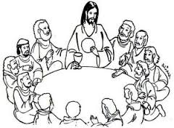 On the night before he died,

when darkness had fallen,

Jesus took bread.

He gave thanks, broke it,

and shared it with his disciples, saying:

'This is my body, given for you.

Do this to remember me.'

After they had eaten, he took the cup of wine,

gave thanks, and shared it with his disciples, saying:

'This is my blood, poured out for you and for many,

for the forgiveness of sins.'

So Father, with this bread and this cup we celebrate Jesus’ love,

his death, his risen life.

As you feed us with these gifts, send your Holy Spirit,

and change us more and more to be like Jesus our Saviour.

**Pupil’s Question: How do we follow Jesus Christ?**

**Pupil’s Answer: Listen, and we will hear.**

Help us, Father, to love one another,

as we look forward to that day when suffering is ended,

and all creation is gathered in your loving arms.

And now with all your saints

we give you glory, through Jesus Christ,

in the strength of the Spirit, today and for ever.

**Amen.**

*The Lord’s Prayer*

As our Saviour taught us, so we pray

**C:\Users\fwilce\AppData\Local\Microsoft\Windows\Temporary Internet Files\Content.IE5\VKAPA31A\MC900048046[1].wmfOur Father, who art in heaven, hallowed be thy Name,  
thy kingdom come, thy will be done,**

**on earth as it is in heaven.  
Give us this day our daily bread.   
And forgive us our trespasses,  
as we forgive those who trespass against us.  
And lead us not into temptation, but deliver us from evil.  
For thine is the kingdom,**

**and the power, and the glory,  
for ever and ever. Amen.**

*Giving of Communion*

Come and share our special meal.

Remember with us the last meal of Jesus and his disciples

and give thanks to God for all that he has done.

|  |  |
| --- | --- |
| *The pupils newly admitted to communion receive first,*  *then all are invited to come forward to receive communion. (Gluten-free bread is available)* |  |

|  |
| --- |
| *While people receive communion, the school sings ‘The Last Supper’ song* |

*Prayer after Communion*

God of mercy,

by whose grace alone we are accepted

and equipped for your service:

stir up in us the gifts of your Holy Spirit

and make us worthy of our calling;

that we may bring forth the fruit of the Spirit

in love and joy and peace;

through Jesus Christ our Lord. **Amen.**

**Sending Out**

|  |  |
| --- | --- |
| **Song 59: I the Lord of sea and sky** |  |

*The Blessing, led Rev’d Pippa*

The God of hope fill you with all joy and peace in believing;

and the blessing of God almighty,

the Father, the Son, and the Holy Spirit,

be upon you and remain with you always. **Amen.**

*Mrs Wilce gives those newly baptised and admitted to communion a candle lit from the Paschal candle and says*

|  |  |
| --- | --- |
| God has delivered us from the dominion of darkness  and has given us a place with the saints in light.  You have received the light of Christ;  walk in this light all the days of your life.  **Shine as a light in the world**  **to the glory of God the Father.**  *Rev’d Pippa sends us out*  Go in the light and peace of Christ.  **Thanks be to God.** | Image result for candle black white Clip Art |

*Mrs Wilce and Rev’d Pippa leads those newly baptised and admitted to communion out of the church for photographs.*

*Visitors are welcome to come over to school for refreshments.*

*No collection is taken during the service, but there will be a plate at the door for those who would like to contribute to the church financially.*

Material used in this service is copyright and has been taken from *Common Worship: Christian Initiation,* *Common Worship: Additional Eucharistic Prayers* and *Common Worship: Christian Initiation additional baptism texts in Accessible Language*  © The Archbishops Council 2006/2012 and 2015 respectively.