And they were amazing!

God made bees!

Bee facts:

1. Bees are related to the ant.
2. Bees have 5 eyes and 6 legs.
3. Bees can see all colours except the colour red.
4. Honey bees harvest nectar and pollen from flowering plants.
5. Male bees in the hive are called drones and they do not have a stinger.
6. Worker bees are females. They do all the different tasks needed to operate and maintain the hive. If a worker bee uses her stinger, she will die.
7. Swatting at bees causes them to release pheromones that call for more bees.
8. Honey bees live in large groups called colonies.
9. An average beehive can hold around 50,000 bees.
10. The queen bee lays all of the eggs in a colony. At the height of the season, she may lay over 2,500 eggs per day! The queen fertilizes each egg as it is being laid. The queen occasionally will not fertilize an egg. These non-fertilized eggs develop into male drones.
11. Honey bees are fab flyers. They fly at a speed of around 25km per hour and beat their wings 200 times per second, which makes the buzzing noise you hear around a bee!
12. The average worker bee lives for just five to six weeks. During this time, she’ll produce around a twelfth of a teaspoon of honey.
13. The queen can live up to five years.
14. Honey bees are also brilliant boogiers! To share information about the best food sources, they perform their ‘waggle dance’. When the worker returns to the hive, it moves in a figure-of-eight and waggles its body to indicate the direction of the food source.
15. Bees have two stomachs - one stomach for eating and the other is for storing nectar.
16. Bees are the only insect in the world that make food that humans can eat.
17. Nectar from about 2 million flowers makes 0.45kg of honey.
18. A hive of bees will fly 90,000 miles, the equivalent of three orbits around the earth to collect 1 kg of honey.
19. Honey has natural preservatives and bacteria can't grow in it.
20. Honey was found in the tombs in Egypt and it was still edible!

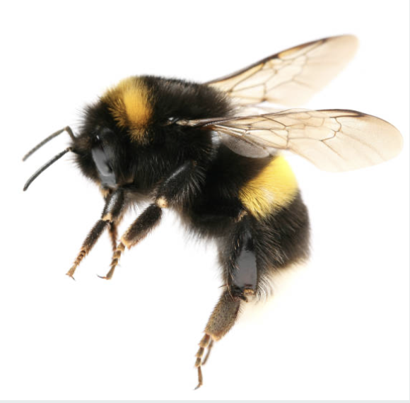

The bee