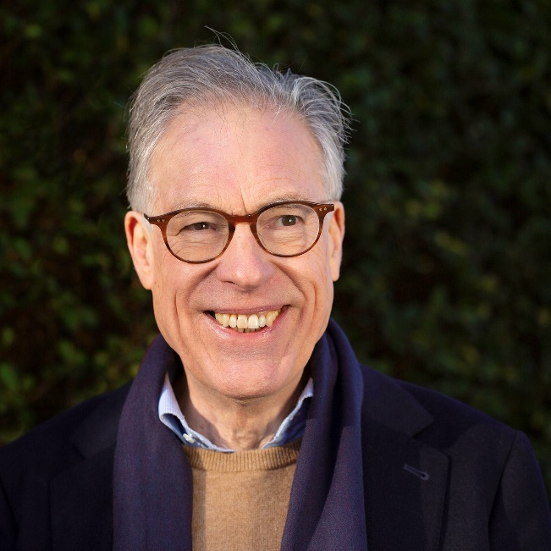Dr Bill Mitchell is a consultant clinical psychologist, educator and author.   Bill’s focuses on building resilience, helping his clients develop a sustainable balance to life regardless of the pressures.  Bill and his team run sessions with corporate clients at the leadership and senior manager level and graduate recruits in professional services firms.  The comprehensive client base includes regulators, banking, education, media, the utility sector, and supporting HR professionals, Occupational Health doctors, health & safety advisors, all of which enable Bill and his colleagues to create positive change in the workplace. Bill teaches at Judge and London Business Schools, Kings College London and more widely in research communities, including Wellcome Trust and the Sanger Institute. Bill is a regular contributor to The City Mental Health Alliance.  Dr Bill Mitchell’s book Time to Breathe was published last year and is available from Bloomsbury and Amazon.

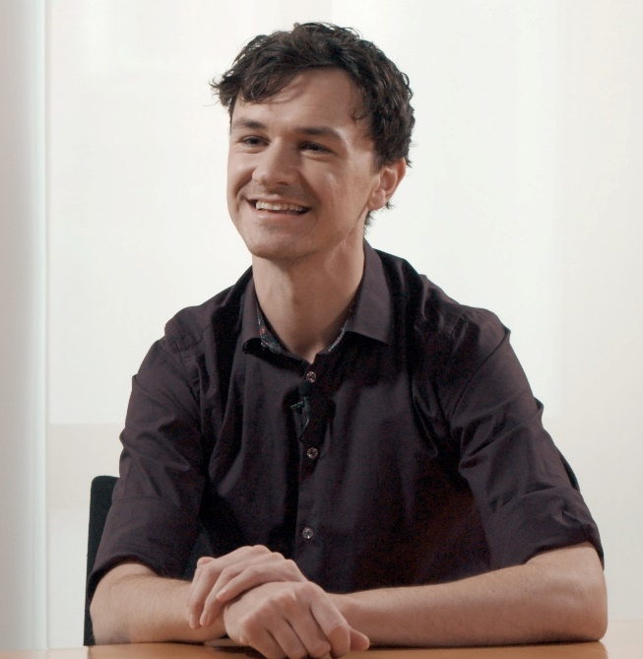Richard Crellin is the Policy and Research Manager for well-being at The Children’ Society leading the team who produce the annual Good Childhood Report. This report provides the most authoritative snapshot of how children themselves feel about their lives in the UK and is a key source for national and local government and other professionals working with children and young people. Richard is an expert in a number of public policy areas relating to children and young people including health, social care, education, social security and immigration. Richard has worked at The Children’s Society for seven years, formerly working for the Sainsbury Family Charitable Trusts. He holds degrees from the London School of Economics and the University of Cambridge. He lives in Hackney in London and is Chair of Governors for Beatrice Tate Special School and an independent visitor for children in care.

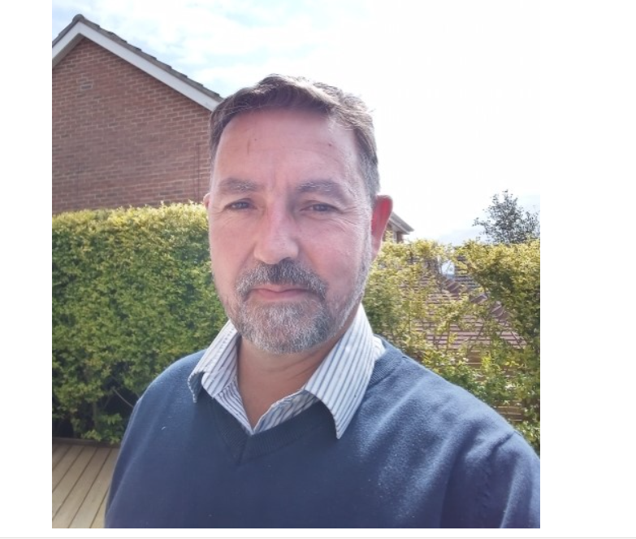Ian Soars is CEO of Fegans, part of Spurgeon’s Childrens charity. Fegans counsel over 450 children every week in over 100 schools and deliver parenting courses, as part of a holistic service to families who are struggling. In addition, Fegans has a substantial digital presence reaching over 500,000 families every year with counselling, advice, innovative resources, courses and support, the vast majority of which is provide free at point of need. Together with local communities, Fegans has developed family hubs based in schools, preschools, churches and across whole towns, that equip local people to do extraordinary work with children and parents who are struggling most, whilst compassionately and frankly addressing some of the more complex issues facing our children today.

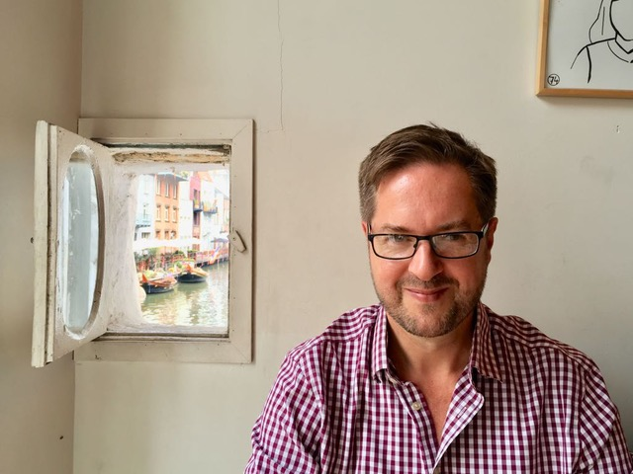Chris Whittington is the founder of the School of Contemplative Life. He was introduced to meditation at the age of 19 during a period of formation at a Benedictine monastery, after which he studied at the Dalai Lama’s monastery in India. Chris regularly delivers talks, workshops and training across the UK and has introduced meditation to the leaders and staff of hundreds of schools. Chris is also Head of Education Law at Anthony Collins Solicitors, a unique social purpose law firm working with schools, academies and dioceses across the country.

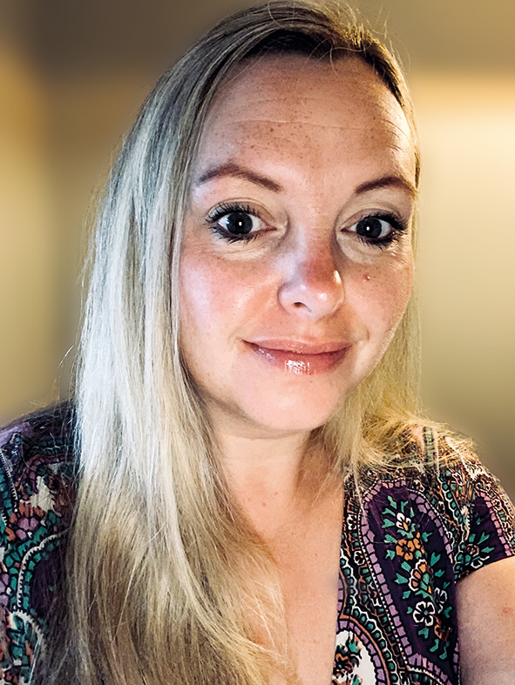Emma Connor has a Masters degree in Integrative Child Psychotherapy, which she studied at The Institute for Arts and Therapy in Education, Emma is accredited by the UKCP. As well as practicing as a child psychotherapist and supervisor in primary schools, Emma is a Director, Consultant and Trainer for Your Space Therapies Limited.

Emma has worked with children for over twenty years starting her career in therapy by working for Childline. Emma then went on to specialise in bereavement work by working for CRUSE bereavement care and providing support for children and adults. Emma’s background is mostly in education having worked as a specialist attachment teaching assistant during her psychotherapy training, and she has had extensive experience in working with children who have learning disabilities and emotional difficulties.

Emma is also a senior lecturer and a member of the exam panel for the Child Psychotherapy Masters and Child Counselling Diploma at The Institute for Arts and Therapy in Education.

Emma was a finalist in the FPM International Medical Writing awards 2020 following her successful blog for PESI UK, ‘Supporting Schools After Lockdown.’

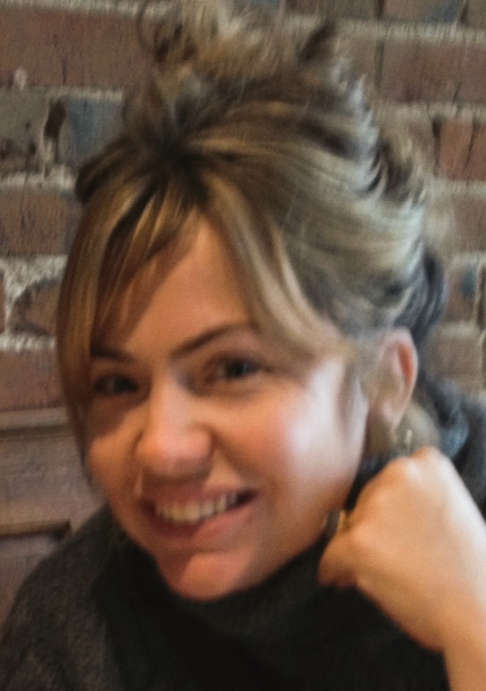Suzanne Ryan has worked psycho-therapeutically with traumatised children, young people and families for 25 years. Before setting up Your Space Therapies 15 years ago, Suzanne worked as a therapist in a range of settings and has gained a wealth of experience, including specialist inpatient psychiatric hospitals for adolescents, residential substance misuse services for families and residential domestic violence projects for children and their families, residential special needs schools and schools with the most disadvantaged children and families in inner city areas.

Since setting Your Space Therapies, Suzanne has been dedicated to ensuring schools, commissioners and parents have access to the best specialist, high quality therapy for children, young people and whole school communities at a price that is affordable and not for profit. Suzanne is passionate about partnership working and good communication between therapists, schools and parents which enables schools and parents to use strategies to build on the therapeutic work and provide the best outcomes for children, young people, families and whole school communities.