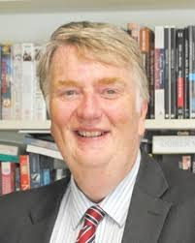Revd Prof David Wilkinson is currently Principal of St Johns College and Professor in the Department of Theology and Religion at the University of Durham, England.  His background is research in theoretical astrophysics, where he gained a PhD in the study of star formation, the chemical evolution of galaxies and terrestrial mass extinctions.  He is a Fellow of the Royal Astronomical Society.  He also holds a PhD in Systematic Theology.

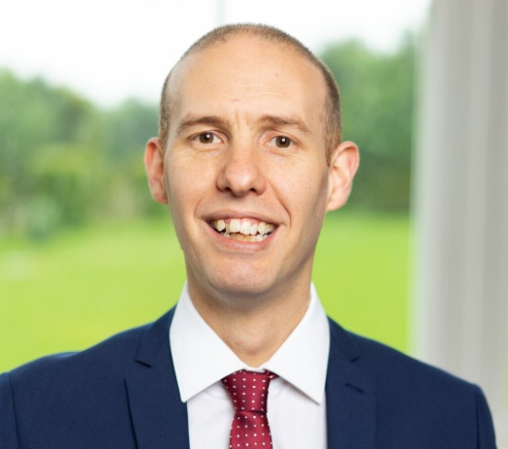Matt Pritchard is a science magician and is on the God and the Big Bang team as the Church-School Link coordinator. Previously Matt conducted atomic physics research at Durham University. He subsequently went on to work within the Education Department at Thinktank Science Museum, Birmingham. In addition to this experience, he has spent the last 20 years working as a professional magician, is an Associate of the Inner Magic Circle, and in 2021 he won the international Best Illusion of the Year Contest. Matt is a Fellow of the Professional Speaking Association.

He attends a community church in Birmingham with his wife and children.

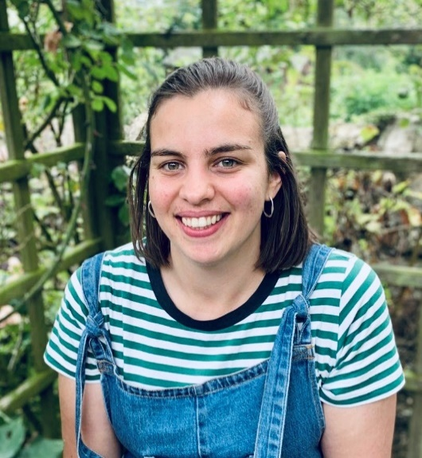Sarah Moring is one of the Schools Development Officers in the God and the Big Bang team. She started working with the project after completing a degree in Pharmaceutical Science at the University of Lincoln and a Masters degree in Science Communication at Imperial College London. Sarah has always loved asking questions and finds joy in the mysteries both science and faith have to offer. She is part of the Young Christian Climate Network and is part of the youth team at her church in Manchester.

Steph Bevan is also a God and the Big Bang Schools Development Officer.  Steph graduated in Physics and Music at Cardiff University before training to be a Physics Teacher at the Institute of Education, London. After several years of teaching, she also works for the Institute of Physics as the Public Engagement Manager for Wales and as a Trustee of the Kepplewray Centre, a Christian Outdoors Centre based in the Lake District. Steph can most often be found somewhere outdoors either climbing, kayaking or cycling.

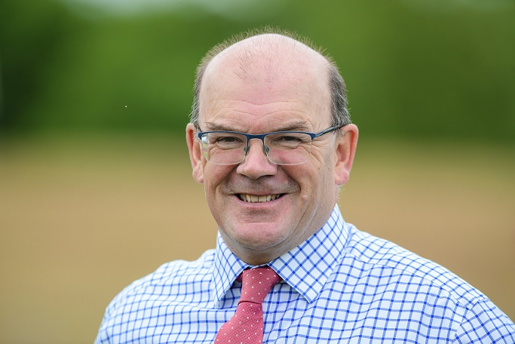Stuart Burns took up post as Chief Executive of the David Ross Education Trust in July 2020. A teacher of 28 years, 15 of which have been spent as a head or chief executive both in the UK and abroad, Stuart was previously the Founding Principal of Bobby Moore Academy in the David Ross Education Trust on the Olympic Park. During this time, Stuart established excellent working relationships with DfE and ESFA, as well as chairing several academy boards and providing executive leadership to help integrate new academies during a period of growth for the Trust. Stuart is a firm believer in combining high academic and pastoral standards with sport, music and other wider interests to help prepare young people for their next step in life.

Fiona is a primary RE specialist. Before joining RE Today as National RE Adviser she was a primary teacher for 15 years and then the RE and primary Adviser for a local authority. She has written and edited a variety of publications designed to support primary RE teachers, including Agreed Syllabuses and curriculum resources. She is currently the editor of the multi-disciplinary Curriculum RE series Big Questions, Big Answers. She was also one of the writers and is one of the key trainers on the Understanding Christianity resource. Fiona is a highly regarded, knowledgeable, inspiring and nationally renowned adviser. She trains hundreds of teachers, heads and governors each year in schools, dioceses, MATs and local authorities. Fiona is also the Chief Executive Officer for NATRE and her involvement in RE at a national level includes lobbying to the government to support RE and liaising with Ofsted. Locally she was involved in writing and training schools on the Peterborough Diocese Agreed Syllabus, and has supported many schools in our diocese.