And they were perfect!

God made

birds!

Bird facts:

1. As of 13 February 2024, there are 634 species of birds on the British List
2. The tallest bird in the UK right now is the Common Crane, which stands at a height of 120cm.
3. Blackbirds are one of the most common birds in the UK, and the males have a distinctive black coat with a bright orange beak. The female of the species displays a more modest brown coat. You will often see blackbirds in your garden in pairs, a male and a female together. These birds generally mate for life and they are capable of having more than one brood in a single year!
4. Many British birds also store food ready for the colder seasons of the year. Coal Tits for example will hoard seeds and save it for when food is less readily available in the environment.
5. Starlings are very common birds in the UK, and they can easily be recognised by their dark colouring with white speckles that resemble stars. Perhaps the most impressive thing about these birds is that they will often gather in large groups in the evenings and dance around in the sky making amazing patterns.
6. Feathers are one of the most defining features of birds, and you may be surprised to learn that their function is for more than flying. Feathers not only help birds to fly, but they are also used for camouflage against predators, to attract mates, and to protect birds from the cold. It is common for birds to take on a brown colour to their feathers as this will easily blend in with the earth, and males will generally show off more colourful plumage to attract females.
7. On average, our common garden birds live between 2 -5 years.
8. Typical flying speeds of some common birds are: House sparrows 17-24mph, Woodpigeons 37mph, starlings 19-22mph, blue tit 17mph
9. Sparrows are small birds and can reach 10-15cm in length and 30g in weight.
10. Sparrows can swim! They can swim very fast to escape from predators.
11. Female sparrows lay 3-5 eggs and the incubation lasts 12-15 days. Both parents take care of the eggs and chicks. The fledglings leave the nest about 15 days after birth. The parents then have another brood. They usually have 2-3 broods per year.
12. They take dust baths. Often, they will make small indentations in the ground and will defend their dust bath spot from other sparrows.
13. Sparrows hop on the ground rather than walk.
14. Sparrows do not migrate. They rarely move more than 1.2 miles from their birthplace.

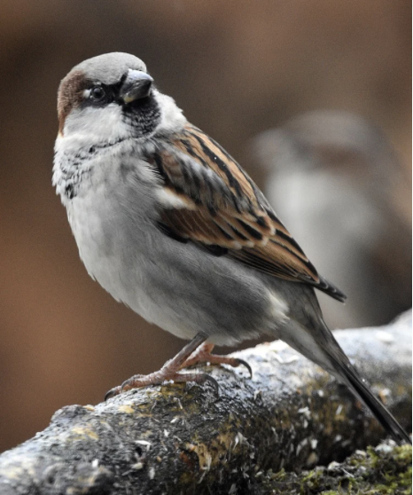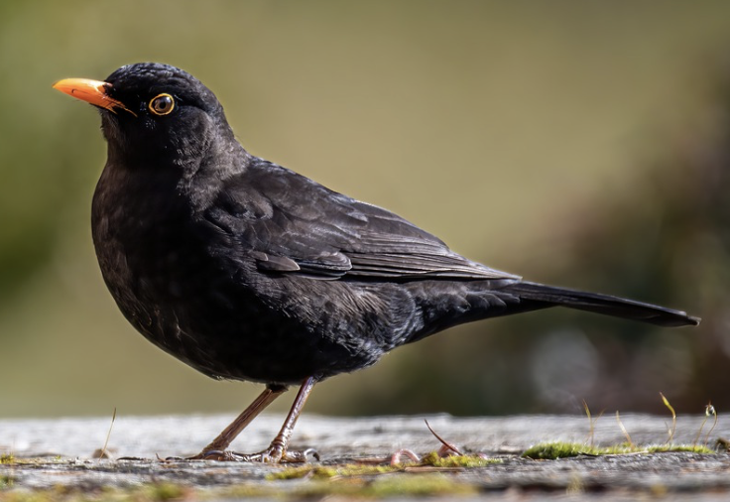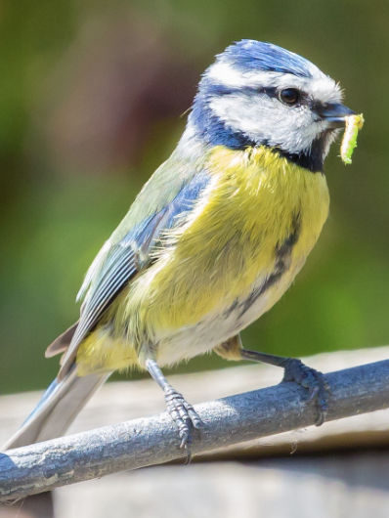

Birds