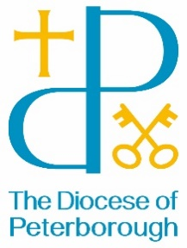BISHOP’S LETTER 19

16 July 2024

Dear Friends,

Sitting around a firepit at Launde Abbey last week, the leader encouraged us to share stories. I was joining the ordination retreat and accompanying those who were to be ordained as priests and deacons. Whether it was the cool evening breeze, the beauty of the landscape, the flicker of the fire, there was something in the atmosphere, and I dare to suggest it may have been God’s hand at work, that allowed each person to speak of moments of significance in their faith journey.

Storytelling has a long tradition, especially sitting round fires. When we tell stories, we draw people into a place of openness and wonder, listening to different experiences and even different cultures. Our imaginations are taken to new places and we can put ourselves in someone else’s shoes for a moment. Our horizons are widened and we are brought closer in fellowship.

Jesus told many stories – he spoke of things familiar to help people understand the Kingdom of God – and spoke in ways that encouraged people to ask further questions. ‘The Kingdom of God is like a mustard seed, a man who scatters seed on the ground, a woman who loses a coin and searches the house for it…’ Perhaps you know many of these stories, perhaps you only know a few, but each time we read them we are able to gain insights into the nature of God and are filled afresh with wonder and awe. Jesus shares his story and we too can share ours. I wonder how we can find those firepit moments when we, too, can sit and listen to others and dare to say something of our own experience of God’s love in our own lives.

You will see my invitation to our celebration of 30 years of Women’s Ministry in this edition of PDN. I look forward to welcoming you to the Cathedral in September where we can share the stories of women’s ministry in our Diocese and celebrate the impact that ministry has had on our lives and our communities.

With best wishes

The Right Reverend Debbie Sellin

Bishop of Peterborough