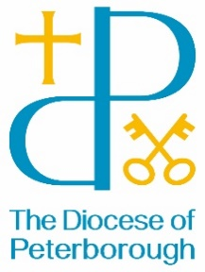BISHOP’S LETTER 21

11 September 2024

Dear Friends,

St Francis, one of the best known saints, is remembered in the church’s calendar on October 4th. Born into a family of great wealth, Francis turned his back on power and status when he encountered Jesus for the first time and went on to a live a simple life, whilst inspiring those whom he encountered as well as the many generations who have continued to read his words and shaped their lives by them. He is probably best known as someone who cared for animals and many paintings show him in his brown habit surrounded by a variety of creatures. Francis founded a men’s Order of Friars and a women’s Order of St Clare and those communities exist still today, with others joining as companions.

Francis had utmost faith in what God was able to do and once said this:

*‘Start by doing what’s necessary; then do what’s possible; and suddenly you are doing the impossible’.*

This was true in his own life when he found resources to restore three chapels that had fallen into disrepair. He also staged one of the first ‘live nativity scenes’ as a way of helping people understand the Christmas story more fully and to engage with it in a new and more personal way.

I wonder what we might see God doing in our lives if we’re to start by doing what is possible whilst believing that God will do the impossible through us. Let’s dream dreams, like Francis did and rejoice as God does more than we could ever expect or imagine.

With best wishes

The Right Reverend Debbie Sellin

Bishop of Peterborough