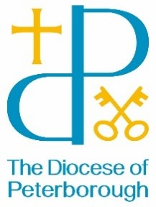
BISHOP’S LETTER 24
17 December 2024

Dear Friends,
And there were in the same country shepherds abiding in the field, keeping watch over their flock by night.
There is a lot of ‘watching over’ in the Christmas story:
- Joseph watching over Mary
- Mary watching over her first-born
- Shepherds watching over their sheep
- Kings watching over stars
- Stars watching over kings
And overseeing all is God, who holds the overarching picture and shelters all under his outstretched arm. The hand that rests on Mary’s shoulder is God’s. The life-giving heat that flows from the shepherds to the sheep is God’s. The deep love that Mary bestows on her newborn son is God’s.
This Christmas, God watches over us, he sees us and beckons us to see afresh his love made flesh on earth in the form of a tiny baby. As you celebrate, I pray that you may know his presence, his care and his love more deeply.
And the word became flesh and lived among us, and we have seen his glory
With my prayers and best wishes,

The Rt Revd Debbie Sellin
Bishop of Peterborough

