
BISHOP’S LETTER 25
14 January 2025

Dear Friends,
We find ourselves once more at the beginning of a new year with all the heartfelt resolutions, many of which will have been made and broken before the end of day one! Yet still we continue to make resolutions, not just at New Year, they are important because they set out the direction of our heart. They are the expression of our intent. The challenge is to actually bring about that intent and this is the hard work.
Each year this time is held in the season of Epiphany, the continuation of Christmas, together these two seasons give us 40 days of focus on the heart of our faith, God with us, the 12 days of Christmas begin with God in fragile human form and the 28 days of Epiphany lead us through the revealing of God’s love and Glory to the whole world, to every person no matter who or where.
This is just the beginning. God came to us, God loved us, that we might come to God. It is God with us that should shape and direct our heartfelt intention. The Archbishop of York wrote on the Feast of Epiphany speaking of his trust that under God we can look to the future with the great hopefulness in Christ.
In the light of Epiphany and the revelation of God’s love we are aware deeply of the darkness and the Makin report has laid out the pain of abuse suffered by so many victim survivors. The Church of England, every one of us, in every gathering place, has the challenge in 2025 to respond and live in the light and love of Christ. It is not enough to have that heartfelt intention we need to make the light a reality and to do that it will take all of us.
In 2025, as the Diocese of Peterborough, let us seek to live out our faith in ways that bring the light of Christ’s love for everyone into real and concrete experiences for those inside and outside our church communities. By the grace of God may each of us be a part of the story of hope in Christ.
With best wishes
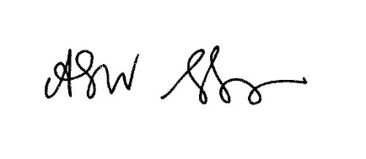
The Venerable Alison Booker
Archdeacon of Oakham

