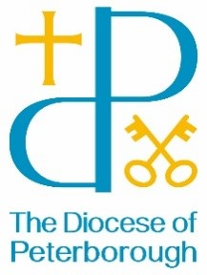
BISHOP’S LETTER 26
11 February 2025

Dear Friends,
“May you live in interesting times” is a phrase that is often called The Chinese Curse. According to the wise of this world (Wikipedia) there is absolutely no evidence of any ancient Chinese origin and the phrase probably came from the British Diplomatic Service in China around 1936. Anyway, wherever the phrase came from, we’re certainly living in very interesting times. The flurry of actions from the Oval Office, continued war In Ukraine, climate change, the freeing of hostages, the massive task of rebuilding Gazza … not to mention the challenges of being part of 21st Century UK. We certainly live in interesting times.
When I left theological college in 1987, the principal preached on Isaiah 6. The chapter begins by noting that King Uzziah had died. It was a time of change. Uzziah was no faultless saint. He got some things very wrong. However, compared to many of his predecessors and successors, he was known to be a good king. As the nation felt the loss of the king, Isaiah had a vision of the King of kings and Lord of lords. And so, back in 1987, our principal reminded us that whatever we face in our ministry and wherever we go … and however hard or easy it is … God is on the throne and will never abdicate. We may live in interesting times – but he calls us and walks with us. Everything is possible.
Henry Ford once said, “Whether you think you can or whether you think you can’t, you’re probably right!” We know that in these interesting times, we walk with the King of kings and Lord of lords. Of course we can. Everything is possible. With best wishes
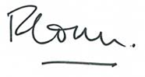
The Venerable Richard Ormston
Archdeacon of Northampton

