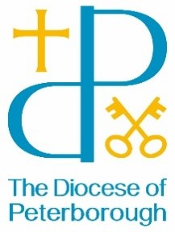
BISHOP’S LETTER 30
10 June 25

Dear Friends,

It has been wonderful to see the many different ways people have responded to Bishop Debbie’s call that this should be a Year with a special focus on Prayer and the “Thy Kingdom Come” initiative.

I’ve been invited to Prayer Days, Prayer Walks, a 24-hour Intercession, a School for Prayer, and, most exciting of all, a Prayer Labyrinth in a garden at Kings Cliffe near Peterborough.

A dozen of us spent a wonderful few hours, walking reflectively along a set path. It was an amazing, shared experience as each of us prayed our individual prayers quietly. My particular reflection was focussed on Jesus’ journey to the cross and resurrection.

The programme explained: “A labyrinth is not a maze! A maze is a puzzle, a path with branches and dead-ends. Only one route will take you to the centre or the other side, most will take you nowhere. A labyrinth is a single long winding path that folds back on itself. At first glance the route may not be clear, but following the path will always take you to the centre … and out again”.

As our guide said: “A maze is a place to get lost in, a labyrinth is a place to find yourself, and to realise that your journey always includes an encounter with God”.

There are turf-cut labyrinths in the Diocese at Lyveden New Bield in Northants (National Trust) and Wing in Rutland. The Lyveden walk is almost a mile long! The Wing trail is much shorter. Further afield, there are pavement labyrinths in the Cathedrals of Ely and Chartres. You can also find printable finger-labyrinths online or buy small hand-held versions.

It’s a lovely way to slow down, reflect and pray. They are truly captivating. I always emerge thinking totally different thoughts, finding the Holy Spirit has guided me. In this Pentecost season of the Spirit, I warmly commend them.

With my prayers and best wishes,


The Rt Revd John Holbrook
Bishop of Brixworth

