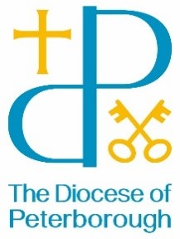
BISHOP’S LETTER 33
9 September 25

Dear Friends,

As a new term begins I am reminded afresh about the amazing work that takes place in our church schools.
I have the amazing privilege of being able to visit many of them and this month will go to two schools that have had excellent results in their SIAMS reviews. These reviews seek to establish how well our schools are maintaining and developing their Christian values and distinctiveness and I am humbled to see just how they well they do this.
Each week around 20000 children and young people take part in collective worship, where they are encouraged to ask big questions of faith and to experience something of the love of Jesus that can then be played out in their lives.
Do please pray for our schools – headteachers and staff, governors and all the children and young people and their families, that the love of Christ will be present throughout.

With every blessing,



The Rt Revd Debbie Sellin
Bishop of Peterborough

