And He said,

that they were

good!

God made caterpillars!

Caterpillar facts:

1. Caterpillars eat a lot, in fact, they can be 100 times larger than when it’s emerged from the egg!
2. Caterpillars have six eyes - they are called ocelli or stemmata. Their eyes can see light but cannot see an image or colours.
3. A caterpillar's gut moves on its own.
4. Most UK caterpillars are not poisonous, however there are one or two exceptions, including the oak processionary moth caterpillar. The hairs that cover these caterpillars hold toxins that can harm people and animals, causing irritation to the eyes and throat, as well as rashes on the skin.
5. Most butterflies transform from their caterpillar selves into butterflies in around 9 to 14 days. However, this does depend on the species of butterfly. It can take different lengths of time depending on the species.
6. It normally takes between 5 and 21 days for a caterpillar to make a cocoon. Then, they stay inside it while they transform. Some caterpillars make a chrysalis and become butterflies, while others make a cocoon before they become moths.
7. A caterpillar lives in a habitat that has lots of plants, trees and flowers, so an adult butterfly or moth can lay its eggs for the process to start again. To look for caterpillars, you may find them on the underside of leaves. They usually hide during the day, using leaves and grass to hide in as they protect themselves from predators -- they come alive at night to feed.
8. Caterpillars do like the sun, but the shade is also needed to keep them happy. A good way to find a caterpillar's habitat is to look for gnawed leaves, this.
9. Did you know that you can find caterpillars pretty much anywhere, including sandy beaches to mountains - you can even find them in some arctic areas?
10. Emperor caterpillar (turns into emperor moth) - This caterpillar is bright green, covered in hairs and has yellow wart-like spots. They feed on plants like bramble and heather which are woody. You can see these between May and August.
11. Peacock caterpillar (turns into a peacock butterfly) - This caterpillar is brightly coloured with small white spots and short spines to protect itself from predators. They can also curl in a ball and drop to the floor, as well as regurgitating a green-like substance to keep predators away. You can see them from May to June.
12. Large White caterpillar (turns into large white butterfly) - This caterpillar is a pale-yellow colour with black spots. The colour is to warn predators that they don’t taste nice. They like to eat large cabbage and can be seen from October to March, although they’re most active in warmer months.

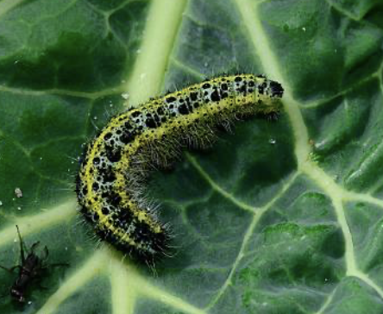

The caterpillar