Charlotte’s Easter Films to share with Children
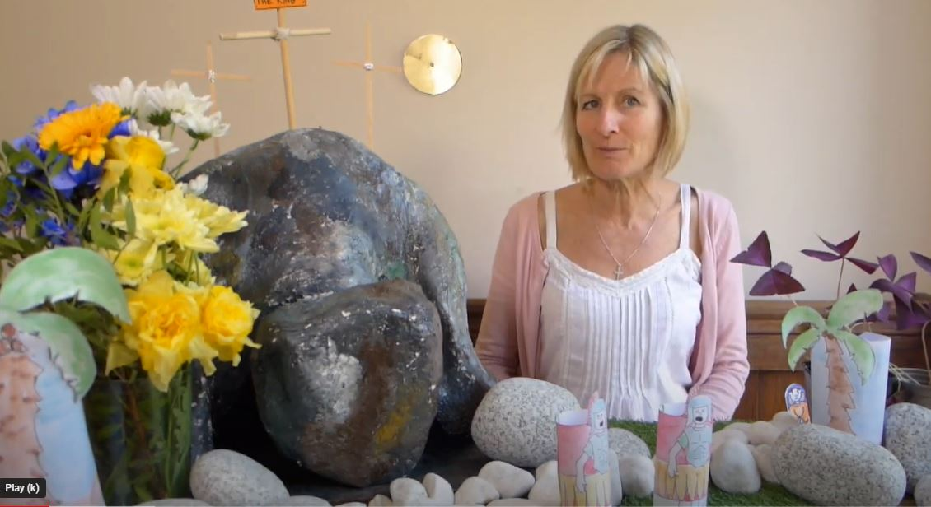
The Story of The Last Supper (youtube.com)
Gethsemane Jesus Prays in the Garden with his disciples (youtube.com)
Good Friday - The Death of Jesus (youtube.com)
Risen Jesus Appears (youtube.com)
Easter Morning - Jesus is Alive (youtube.com)

