Christianity as a Global World Faith


A brand-new resource that aims to work together with Understanding Christianity to challenge the Eurocentric vision of Christianity and celebrate the infinite translatability we can find in the diversity that exists within the Christian Faith.

Those who have trialled the scheme, both in primary and in secondary shared their delight at the impact on their pupils, the depth of their understanding as well as their increased capacity for courageous advocacy.

This inclusive resource is rooted in ubuntu. Ubuntu is a Nguni Bantu term that is usually translated as ‘A person is a person through other people’ or ‘I am because we are.’ In this worldview we can only understand who we are in relationship with other people; only achieve our full potential through that ‘tender network of interdependence’.
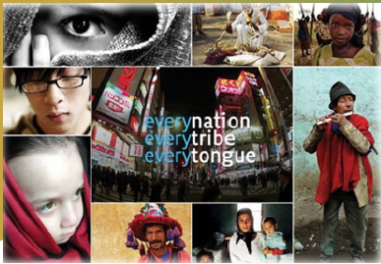
‘We don’t come fully formed into the world. We learn how to think, how to walk, how to speak, how to behave, indeed how to be human from other human beings. We need other human beings in order to be human. We are made for togetherness… to exist in a tender network of interdependence. That is how you have ubuntu – you care, you are hospitable, you’re gentle, you’re compassionate and concerned.’
Desmond Tutu as quoted in Battle 1997:35

Paul Fidler, RE Subject lead at Tanworth-in-Arden CofE Primary school, shared that the resource offered a wide range of videos, stories and suggested activities with common threads, but different perceptions because of the different worldviews encountered.

Gemma Hathaway, Assistant Headteacher at Blue Coat Church of England School and Music College, who used the resource with KS3 and KS5 students noticed their high-level conversations about specific concepts found in sacred texts. She went on to explain that the multidisciplinary approach of the tasks provided led her students to explore the diverse ways people worship or interpret scripture through their different worldviews and experiences.

It is very pertinent to find resources such as this when the latest National Director’s SIAMS Annual Report names ‘Christianity as a global faith’ as the most cited development point in this year’s inspection reports.

Full of authentic case studies from all around the world, these resources will be free to access after a proper training has been completed by the school (at a small fee). The team is finalising the logistics of the training delivery (including its timing, cost and integration with wider approaches to RE training). We look forward to sharing the details with you as soon as they are available.

