Simply Christmas
Idea 1 Angel bomb your village or parish
Ask everyone to knit simple angels for you. Pattern attached; they look like this:
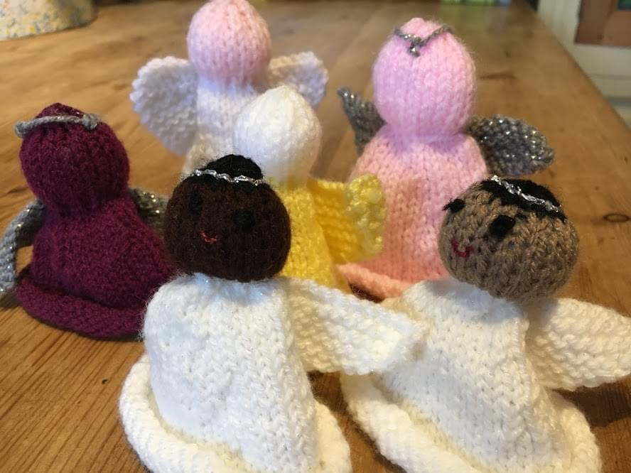
Then label them with something like:
A Christmas Angel for you to keep from the Churches. Go to Kettering Angels Facebook page and tell us where you found it. Happy Christmas!
Set up a Facebook page if your church doesn’t have one and then distribute them around the area during advent. We had over 300 angels knitted for us, and we put them outside schools, in supermarket shopping trollies, on doorsteps, in shops, near old peoples flats etc.
We had a huge response on the church Facebook page and lots of lovely comments such as:
‘Pride of place on our tree, thank you and Merry Christmas’, ‘We found two in Perry wood’s plant pot! Thank you’, ‘Kettering bus stop. I needed this today. I had just left after a rather horrible appointment. At my wits end…. thank you’,
‘Thank you for my beautiful angel. I found it on the railings at the Salvation Army, it made me quite emotional. Such a beautiful idea.’, ‘Loving our little angel found at Youth Works on the first day of our Ofsted inspection.’, ‘My son found one outside the school yesterday; thankfully his sister found one today!’,
St Andrew’s school caretaker found one in Grafton Street and lots of people found them on their doorsteps or in their shopping trolley. A few were found by businesses who all put them in their windows or offices and everyone who posted was pleased, touched and happy.

Idea 2. Travelling Crib in your Toddler group or whole church depending on size.
We have a knitted nativity set that goes out from house to house over Advent and comes back to church on Christmas eve for the crib service.
Last year, for the first time, we sent everything out. We used to just send Mary and Joseph and a donkey as they ‘travelled toward Bethlehem’ but then we thought, if we send it all and a simple nativity story book (we use Dick Bruna’s The Christmas Book’) families can play with the set and learn the whole story. This worked really well. We sent a diary for the families to fill in and they loved it.
To organise we have a sign-up sheet going round during November. We ask our Mother’s Union to knit us 25 small sheep and then each family can have a sheep to keep and put on their Christmas tree to remind them of when Mary and Joseph came to stay.
