From: Burns, Kirsty <kburns@oundleschool.org.uk>
Subject: ExpertEd Webinars Sept-Oct

ExpertEdLive’s free webinars offer schools and pupils the chance to learn through live interaction with experts in a variety of curriculum areas, providing enrichment and curriculum coverage. Schools from across the country connect directly from their classroom via Zoom. Pupils put their questions to our speakers through live Q&As with each event. An overview and some introductory videos may be found on our website www.expertedlive.org.

Best wishes
Kirsty

What’s on | Events for Schools | When | Registration
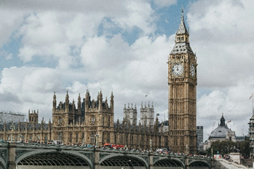  Highlight Speaker: The Rt Hon Lord Knight of Weymouth. | Meet current member of the House of Lords, and previous Labour MP, The Rt Hon Lord Knight of Weymouth. Hear about his role and how the House of Lords works in our democracy. The session is 30minutes long with an interview and live Q&A session for your pupils to participate in. For years 5-8. | Wednesday 11th September 1:30pm (30mins) | Register here.
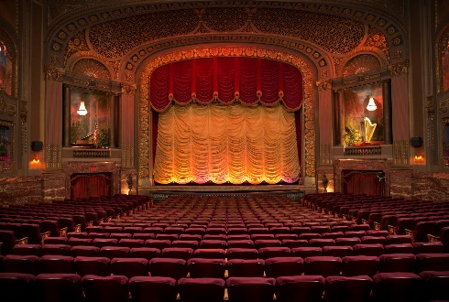  Careers in the Classroom: Performing Arts | This series (one each half term) brings expert speakers from the world of work into the classroom, expanding children’s knowledge of the range of careers available to them. In this session we meet Lucy Key, actress and director, who will explore some of the many roles that work alongside the performer in the performing arts. For years 5-8. | Wednesday 25th September 2pm (30mins) | Register here.

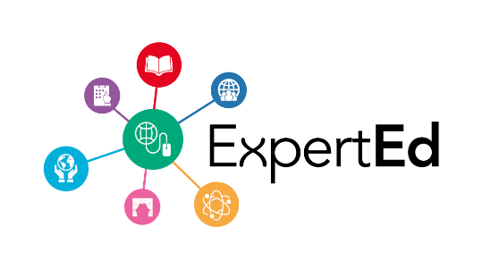
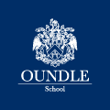 | Kirsty Burns  ExpertEd Administrator  Great Hall, New Street, Oundle, Peterborough PE8 4GH  www.oundleschool.org.uk

