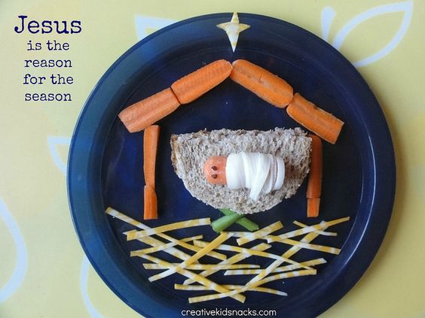

**Create the manger bed for Jesus**

**You will need:**

**Ingredients Equipement**

* **Carrot (sliced so can lie flat) * Star cutter**
* **Bread * Knife**
* **Celery sticks * Paper plate**
* **Crisp sticks * Phone for photo**
* **Cheese slice**

**How to make**

1. **Make a cheese spread/jam sandwich, cut to make manger**
2. **Wrap a carrot baby Jesus in a the ‘string’ peeled from a cheese string**
3. **Eyes of Jesus can be raisins/write-on icing**
4. **Assemble ‘walls’ and ‘roof’ of stable with carrots (sliced to lie flat)**
5. **Cross 2 celery sticks for the support to the manger**
6. **Arrange crisp sticks for hay**
7. **Cut out a star shape from the cheese slice**
8. **Photograph your plate to remember**

**Challenge**

**Can you tell someone the story of how Jesus came into the world as a baby? Why is He such a special baby?**

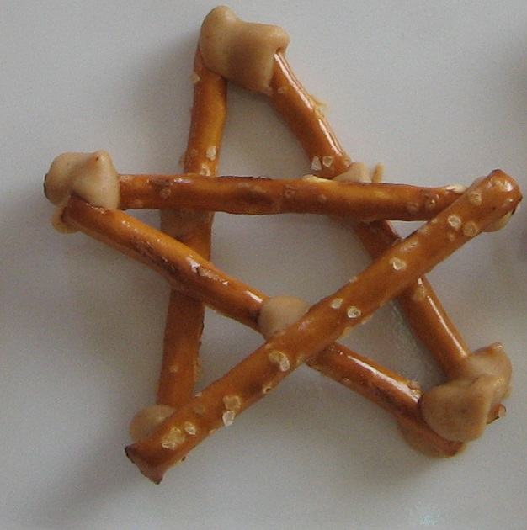

**A Sticky Star**

**You will need:**

**Ingredients**

* **Matchmakers/Stick Pretzels**
* **Chocolate spread/Cheese spread**

**This is very sticky and a bit messy! Can you work out how to stick this star together using 5 sticks and your tasty glue before it falls apart/melts in your hands/you just can’t resist eating all the ingredients?!**

**Have a think:**

**The wise men had to be very patient. They had to travel for miles and miles, for many weeks. They may have got messy’ sticky and dirty. They may have wanted to give up. But they kept going to find the place that the star spotlighted.**

**Why did they keep going? What do you think they saw that made them worship a baby?**

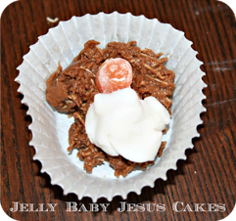

**Manger and Sheep**

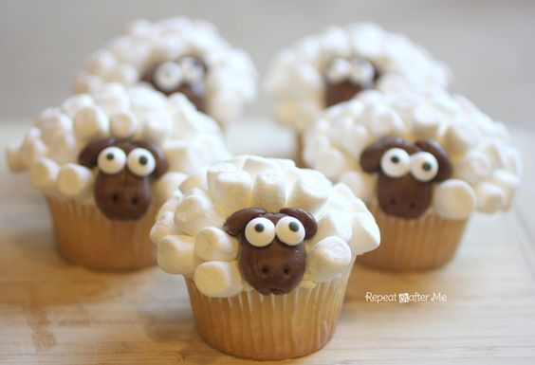

**You will need:**

**Ingredients for Jellly Baby Jesus Cake Ingredients for Sheep cakes**

* **Rice crispies or shredded wheat * Cup cakes**
* **Melted chocolate * Icing/Frosting**
* **Jelly babies * Mini marshmallows**
* **Roll out icing in strips * Giant chocolate buttons (faces)**

**\* Googly edible eyes or white chocolate drops**

**Equipment**

* **Cup-cake cases, bowls for chocolate crispy mixing, t-spoons, wipes, sandwich bags and labels with pens for writing name**

**How to make:**

**The Manger**

1. **Mix up crispies with melted chocolate**
2. **Spoon mixture into cupcake case and use back of t-spoon to make a ‘hay bed’**
3. **Roll up Jelly Baby in a strip of icing and lay him in the manger bed**

**The Sheep**

1. **Cover the top of the cake with icing**
2. **Place chocolate button on front and stick on eyes/drops onto chocolate button face**
3. **Arrange marshmallows for woolly fleece over the rest of the icing**

**Question:**

**Why do you think God’s boy was not born in a lovely home or palace?**

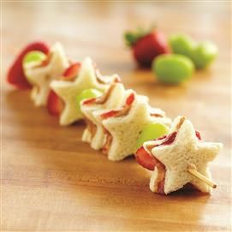

**Follow the Star Kebab**

**You will need:**

**Ingredients: Equipment:**

* **Sliced bread * Wooden Kebab sticks**
* **Spread and Jam/Cheese spread * Star cutters**
* **Strawberries * Knife**
* **Grapes * Paper plates/sandwich bags with labels**

**How to make**

1. **Take 2 pieces of bread and make you sandwich**
2. **Cut the sandwiches into as many stars as you can using the star cutter**
3. **Spear a star sandwich, then a strawberry/grape and arrange your kebab using all your star sandwiches**

**Question:**

**The wise men followed the light of a star to find Jesus. Jesus grew up and said “I am the Light of the World’. What does this mean to you?**