And they were good!

God made hares!

Hare facts:

1. Hares are generally larger than rabbits, with longer ears, larger and longer hind legs and have black markings on their fur.
2. The brown hare, is Britain’s fastest land mammal, clocking speeds of up to 40mph. The hare is a small and timid animal that can outrun predators with incredible bursts of speed and endurance. Thanks to their powerful hind limbs, they can leap 10 feet in the air. They are also excellent swimmers that can traverse rivers and large bodies of water without a problem
3. There are about 700,000 hares in the UK. They live between 4-8 years in the wild.
4. Measuring about 40 to 70 cm from head to tail. The body is complemented with 15cm feet and 20cm ears. The male is known as a jack, while the female is called a jill. Both are fairly similar in size and appearance, though females do tend to be a little larger, which is uncommon for a mammal.
5. Hares are solitary, not colonial, and don’t burrow. They create shallow resting places, in fields or long grass, known as ‘forms’. A family of hares is called a ‘drove’.
6. The phrase ‘mad as a March hare’ is derived from the antics of hares during their breeding season when they box frantically with one another.
7. The best time to see hares is at dawn and dusk, out in open fields, farmland and woodland edges.
8. As hares have excellent hearing, they are good at detecting potential danger through sound. Hares also have a finely developed sense of smell, and vision. Their wide angle of view allows them to detect predators coming from anywhere around them except for a small blind spot in front of their noses.
9. The hare is a nocturnal animal that spends the night awake and the day sleeping.
10. The hare’s front teeth never stop growing throughout its life. The animal must grind the teeth down by chewing on grass.
11. Baby hares are called leverets (baby hares) are born as early as March and often appear in fields looking as though they have been abandoned. It’s vital that you don’t touch them - it’s actually fairly common for leverets to be left alone for long periods of time (their mother will come back and check on them intermittently).
12. Hare tracks look like this:

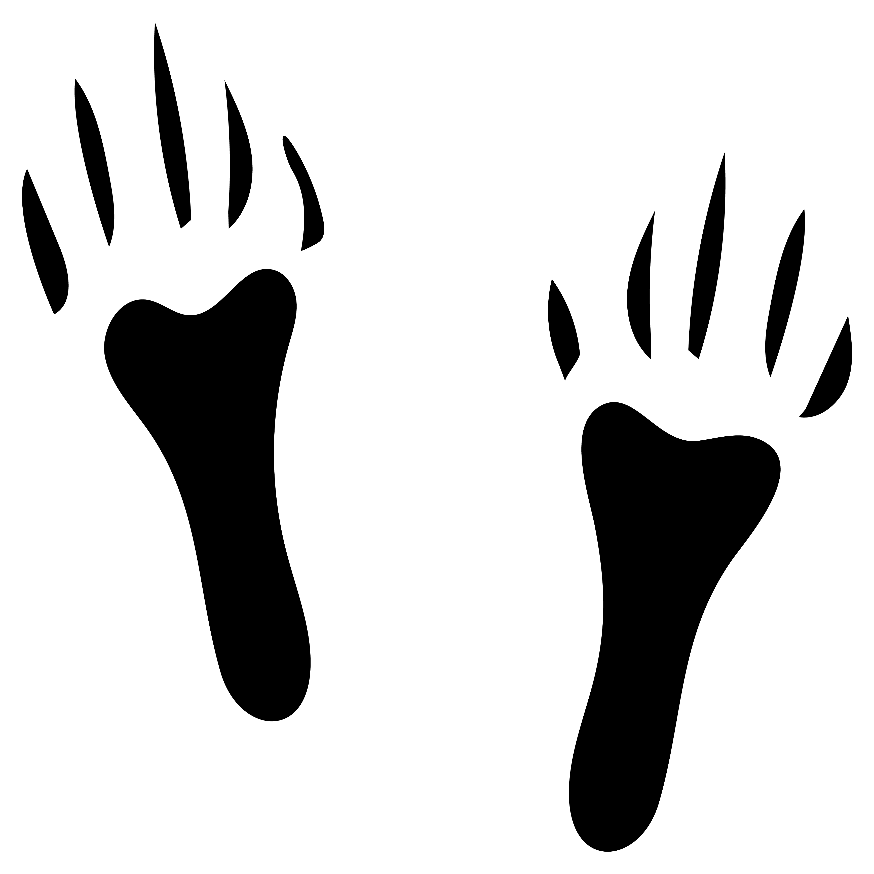

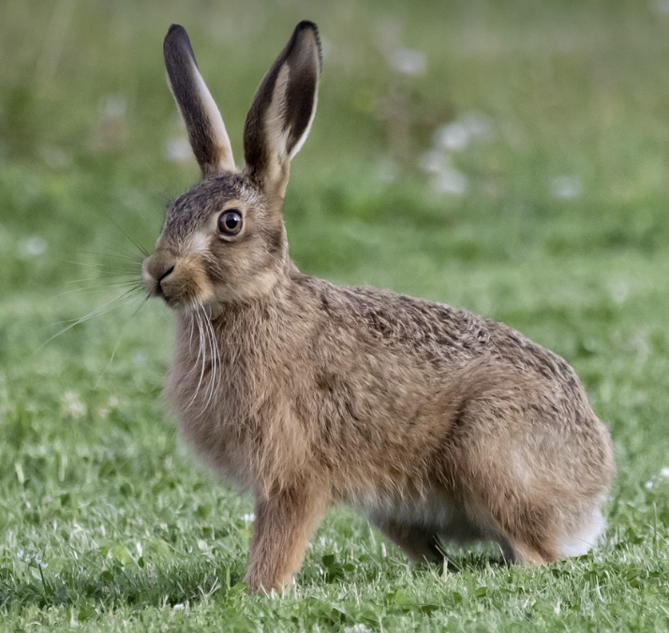

The hare