And they were

perfect!

God made hedgehogs!

Hedgehog facts:

1. There are 17 species of hedgehog. They mainly live in Europe, Africa and some in Asia but they don’t live in America or Australia. The most common is the European.
2. They eat earth worms, beetles, larvae, earwigs, snails and spiders. They can sometimes also eat frogs, baby birds, snakes, bird’s eggs and fruit. Don’t feed them milk (they are lactose intolerant) or dog food as it makes them poorly.
3. They have around 5000 to 7000 spines, which are hollow and can be set up individually. Each spine is about 25mm long When they are born, they already have around 100 to 150 soft spines which harden over the first weeks.
4. Hedgehogs are around 20-25cm long and typically weigh up to 1.2kg.
5. They spend the whole day sleeping and are most active at twilight and during the night.
6. Hedgehogs hibernate starting from late October to early April. Before hibernating, they eat a lot of food to build up fat reserves. Then they search for a frost-free place to be warm and safe. During their hibernation they don’t eat and sleep all the time. They reduce their body functions: metabolism, body temperature, breathing and heart rate.
7. When they are looking for a partner, they can cover around 250 acres (that is 130 football fields)
8. They have a good sense of smell and hearing, but their eyesight is poor.
9. Hedgehogs are good swimmers and proficient climbers
10. Hedgehogs run around 1.8miles per day. With a top speed of around 5mph in short bursts.
11. Their predators are: dogs, owls and foxes. When in danger they curl up quickly
12. The average lifespan of hedgehog is 2-3 years but they can live up to 6 years.
13. Hedgehogs poop a lot as they have a very fast metabolism and when they run it makes them poop! Hedgehog poo is black or very dark brown, roughly sausage shaped, between 1.5 -5cm long, glistening with almost metallic appearance as they often contain insect body parts.
14. Hedgehog tracks look like this:

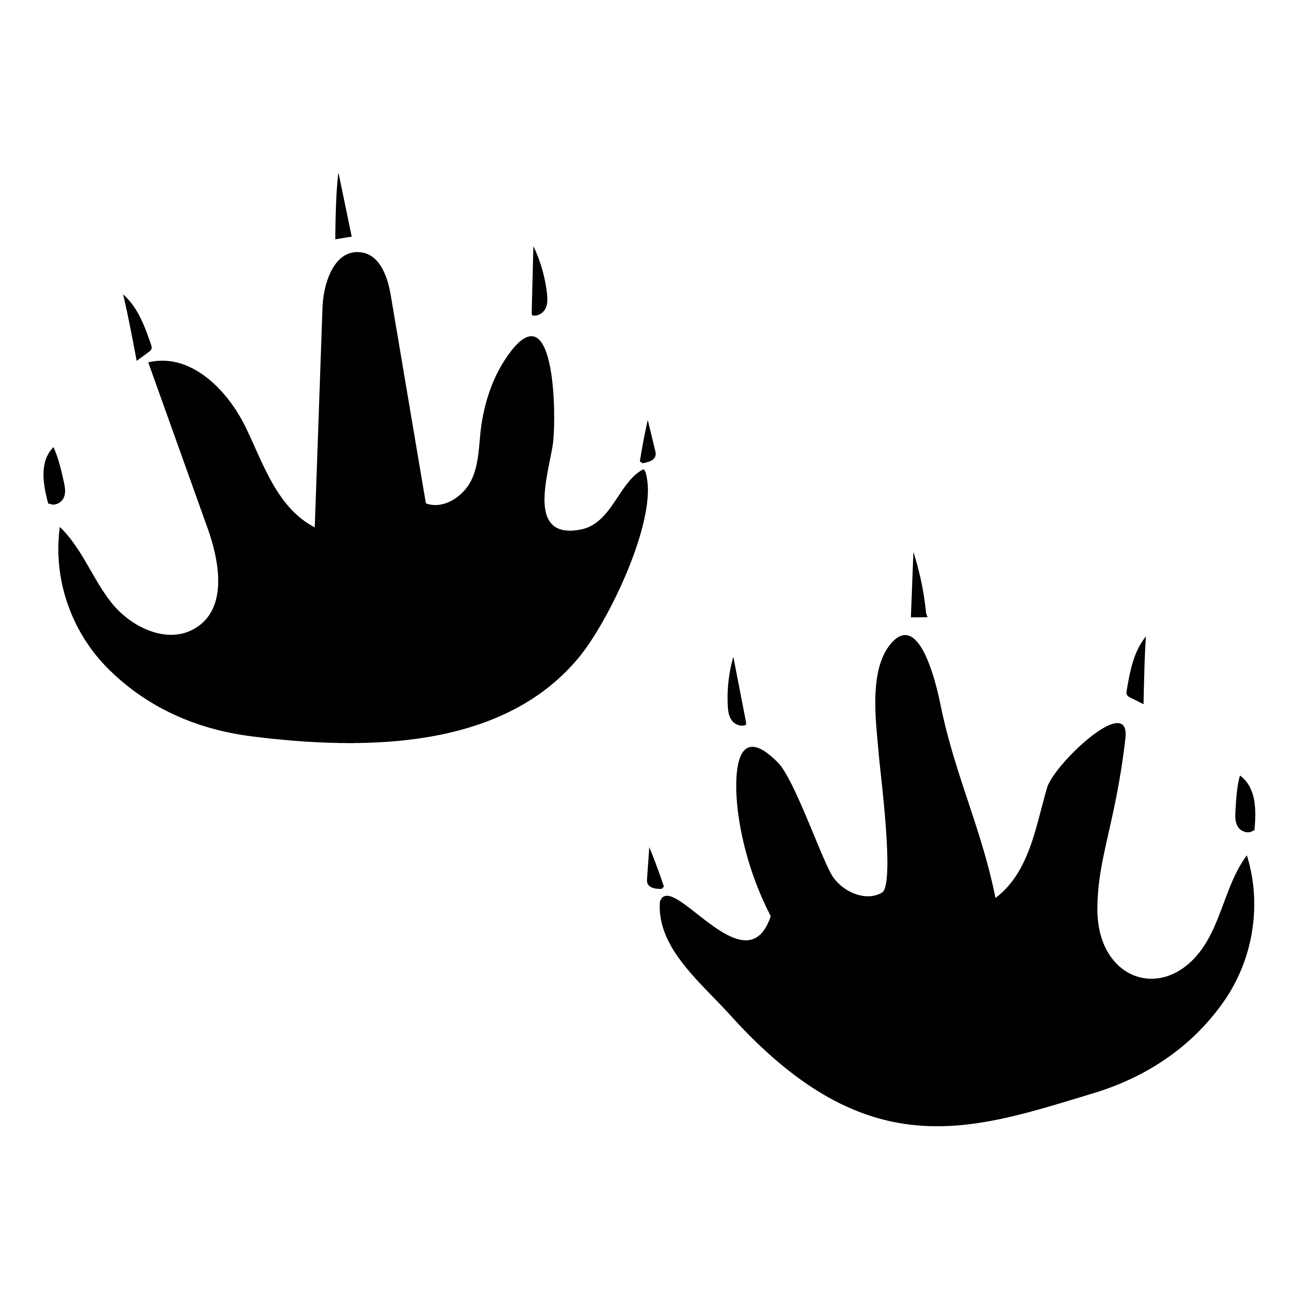

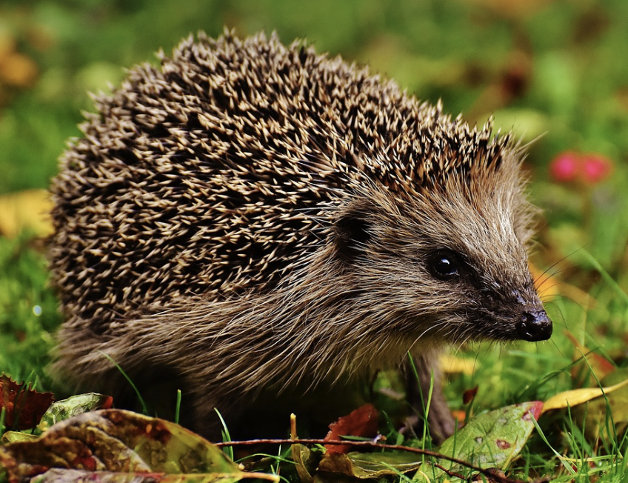

The hedgehog