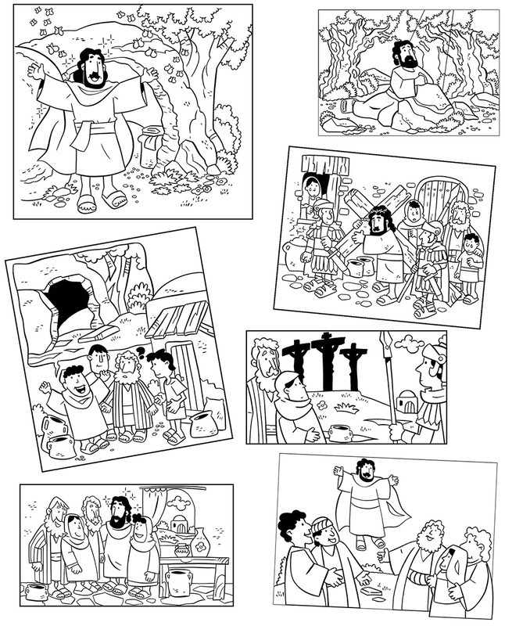

Holy Week pictures to colour and sequence…

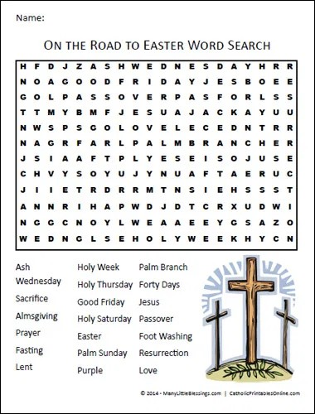

Retelling the Easter story with eggs.

Gather six plastic eggs, each a different color. Place the following items inside, one item per egg: breadcrumb, paper cross, strip of cloth, rock and a sweet.
One egg will remain empty. As you tell the Resurrection story, let your child open the eggs. Explain each item in the following order:

- Bread crumb: Jesus ate dinner with His friends. (Luke22:14-15)

- Cross: The next day, Jesus died on the Cross. (John19:17-18)

- Strip of cloth: He was wrapped in cloth and placed in a tomb. (John 19:40)
- Rock: A stone was placed in front of the tomb. (Matthew27:59-60)

- Empty egg: Jesus’ friends came to the tomb and saw the stone had been moved. The tomb was empty! (Luke 24:1-3)

- Sweet: Jesus is alive. That’s the sweet surprise of Easter. (Matthew 28:5-6)

Copy & paste this link
Watch The Christian Story of Easter

https://www.youtube.com/watch?v=Wnbo2AmS3OI

Prayers with children

A prayer for when a friend is ill
Dear God, (name of friend) is ill.
They are not allowed to go to school or come over to play. I’m sad because I miss them.
They must be feeling miserable and lonely as well. Please be close to them.
Please be with the people who are looking after them.
Please help them to get better and to know that you love them.

Amen.
A prayer for the world
God of love and hope,
you made the world and care for all creation, but the world feels strange right now.
The news is full of stories about Coronavirus. Some people are worried that they might get ill. Others are anxious for their family and friends. Be with them and help them to find peace.
We pray for the doctors and nurses and scientists,
and all who are working to discover the right medicines to help those who are ill.
Thank you that even in these anxious times, you are with us.
Help us to put our trust in you and keep us safe.

Amen.
A prayer at bedtime
Before the ending of the day, Creator of the world, we pray
That you, with steadfast love, would keep Your watch around us while we sleep.
Tonight we pray especially for (names family or friends who are affected by Coronavirus) and the people of (country or place which is affected by Coronavirus).
Please give skill and wisdom to all who are caring for them.

Amen.

A prayer remembering God is with us
Lord God, you are always with me.
You are with me in the day and in the night.
You are with me when I’m happy and when I’m sad. You are with me when I’m healthy and when I am ill.
You are with me when I am peaceful and when I am worried.
Today I am feeling (name how you are feeling) because (reasons you are feeling this way).
Help me to remember that you love me and are with me in everything today.

Amen.

Listen to -Easter Songs & Easter Songs For Children: Collection 1 of Easter Music For Children
Copy & paste this link

https://www.youtube.com/watch?v=v-bsOgo8LGo

Prayer ideas to fill in with your child…..

Make your own Holy Week mobile, cut out & colour

