And they were perfect!

God made ladybirds!

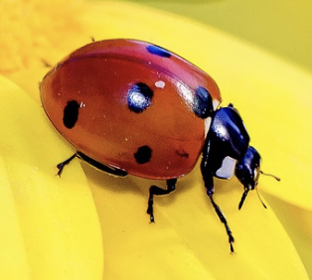

Ladybird facts:

1. Ladybirds are a type of beetle.
2. The most familiar in the UK is the seven-spot ladybird, which has a shiny, red-and-black body.
3. Most people like ladybirds because they are pretty, graceful and harmless to humans. But farmers *love* them because they eat aphids and other plant-eating pests.
4. A lady bird will live for a year during which a single seven-spot ladybird can gobble more than 5000 aphids!
5. The ladybird’s bright colours act as an important defence mechanism, warning animals they’d best not eat them. When threatened, they secrete an oily, yukky, yellow fluid from joints in their legs – and their colouring acts a reminder to any peckish predators who’ve eaten their kind before that they taste disgusting!
6. These brilliant bugs have another trick to avoid danger, too – remain still and pretend to be dead.
7. Birds are ladybird’s main predators, but they also fall victim to frogs, wasps, spiders and dragonflies.
8. Ladybirds lay their eggs in clusters or rows on the underside of a leaf, usually where aphids have gathered. Larvae, emerge in a few days. Seven-spot ladybird larvae are long, black and spiky-looking with orange or yellow spots – some say they look a bit like small alligators! Larvae grow quickly and shed their skin several times.   This happens after it has eaten so much that its skin becomes too tight! When they reach full size, they attach to a leaf by their tail, and a ‘pupa’ is formed. In only a week or two later, the pupa becomes an adult ladybird.
9. Ladybirds hibernate during the colder months of the year and usually settle down in the crevices of trees. In the UK this usually happens between December and March. As the temperature falls they become more and more inactive and go to sleep in a dark corner until the winter is over.
10. Ladybird body length: Up to 1cm
11. Ladybird top speed: 24km/h
12. NASA even sent a few ladybugs into space with some aphids to see how aphids would escape in zero gravity.
13. They have two sets of wings. The outer set is the hard shell for protection, and the inner set are what it uses to fly.

The ladybird