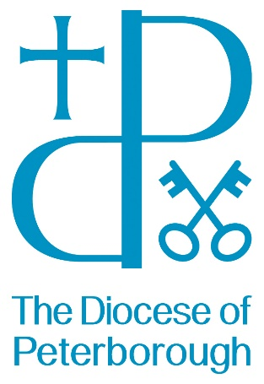
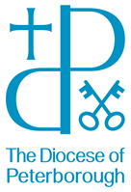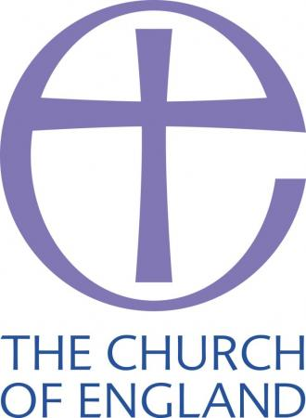

Lay Pioneer
Certificate

This training is for three types of people:

- If you are thinking about starting
something new to reach out to those who don’t come to ‘regular’ church
- If you have already started something
but wish to learn more and see your project continue to grow
- If you are wondering whether you have
a bit of a pioneer in you and wish to discern God’s calling more clearly

Upon satisfactory completion of the training, you will receive a Bishop’s Certificate, and, with your incumbent’s support, qualify you to be commissioned as a Locally Authorised Pioneer.

What the training includes:
There are three modules spread out over 9-12 months, to be taken in any order.

Module 1:
Introduction to Studying the Bible for Mission
Inter-actively exploring God’s mission in context for then and now. From reluctant missionaries (Jonah), social engagement (Ruth), telling Jesus’ stories (Gospels) and tensions amongst new believers (Epistles), there is so much to learn.

Led by Revd Yvonne Desroches and Revd Haydon Spenceley.

Module 2:
Covering the key stages from working out what to start, gathering a team, setting out, building community, and exploring discipleship. These sessions will include not just the theory but stories from pioneers, as well as time to plan and pray for your project.

Module 3:
Pioneer Placements
Spending time with an experienced pioneer over a couple of months, learning from their experience, assisting them and reflecting on how this could work in your context. There will also be the opportunities to do some ‘one-off’ visits to other projects.
Final Presentations & Prayer
Each course member (ideally in a team) gives a presentation to the rest about their project, followed by prayer for each other along with a celebration meal.

SAFEGUARDING and Getting Support from your Church/parish: All our training is done with the knowledge and support of your church leader/vicar. You will need to talk with them and seek their support for you to be part of the training and that you will work under your parish/church safeguarding scheme.

Any Questions? Please do not hesitate to telephone or email …

Course Administrator Course Leader
Nuala Salter Yvonne DesRoches
T: 01604 887 049

E: Nuala.salter@peterborough-diocese.org.uk

Cost and who pays?

£110 is the cost for the Lay Pioneer Certificate.
We ask for your PCC to cover this cost. If another member of your team would like to attend we will split the cost between you.

