Cathedral in Crisis

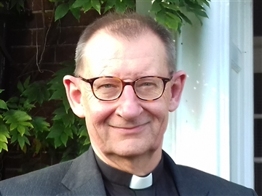
Dear Friends
Safeguarding concerns have presented a big challenge for the Church of England nationally, but, nearer to home, the now well-publicised financial issues facing our Cathedral have helped to bring home the challenge we are all facing, whether as individuals or as parishes, to make ends meet or to fund properly the ministry and mission of our church. Jesus said, “the poor you have with you always” – and it can sometimes seem as if we are always poor! From a Cathedral perspective it’s disappointing to be facing yet another financial pinch point when we’ve done so much to improve our financial management, and been so creative in the delivery of a fantastic array of exhibitions, events and activities. But like every other business, we’ve all of us been facing the same issues; Covid, the cost of living crisis, the rising costs of fuel and employment – they’ve all continued to pile pressure on our balance sheets.
We have launched an emergency appeal here, and we pray that that may be fruitful. But “we are afflicted but not crushed, perplexed, but not driven to despair” writes St Paul in 2 Corinthians, and Jesus again and again called us not to be afraid or anxious because “your heavenly Father knows you need all these things”. The real challenge for us all is not one of systems, or process, or finance or funding – but faith.
Whatever we face as individuals or as communities - and we need to be responsible in our stewardship and disciplined in our actions – but above all we need to renew our trust in the living God: “strive first for the kingdom of God… and all these things shall be given to you as well”. (Matthew 6.33)


The Very Revd Chris Dalliston
Dean of Peterborough

Diocese of Peterborough - Magazine Resource – February 2025
Produced by the Diocesan Office, The Palace, Peterborough, PE1 1YB
Tel: 01733 887000 Email: communications@peterborough-diocese.org.uk
www.peterborough-diocese.org.uk

