Our Shared Calling

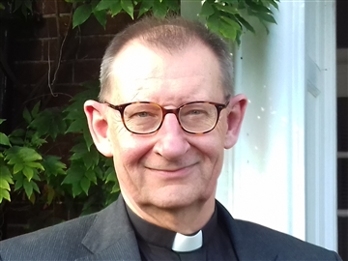
July is the season of ordinations – a time to celebrate those who have been called to special ministries in the life of the Church, as deacons and priests, but also an opportunity to reflect on what God is calling US to be and to do. For us at the Cathedral, the ordinations come hot on the heels of our patronal festival when we remember St Peter, that rather unlikely hero of the Christian faith, who so often seemed not to be the ‘rock’ that Jesus had nick-named him! Nevertheless, Peter managed to come to terms with his past failings, and respond to Christ’s forgiveness, and the call to “feed my sheep”.
It's surely true that none of our new priests and deacons are the finished article either. Like Peter, like all of us, they will have much to learn about themselves, their role and the communities they serve and every new experience and challenge offers all of us an opportunity to learn and grow, if we are humble enough to accept it in that way.
This year the ordination service has a particular resonance for me as I will have just celebrated 40 years as a priest. A lot has changed since the summer day in 1985 when I was ordained. Shops were still closed on Sundays; the ordination of women was still to happen; there was no ‘internet’ mobile phones or social media; it was still likely that people would apologise for not going to church – rather than express amazement that anyone still does!
But in the midst of that, I know I’ve changed and hope that I will continue to do so. Not in the strong sense of calling that I still feel, but in recognising that in a changing world, while the message of Christ’s love remains constant, how that love is to be lived out and the good news of it shared has and will continue to change and develop. All of us are called by the one Spirit of God. May we seek to follow that call and live it out, wherever it leads us.
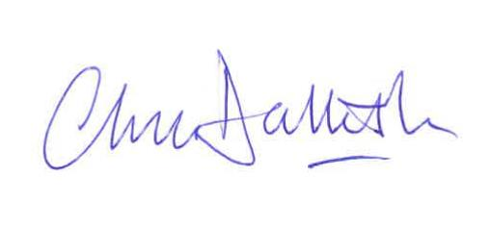
The Very Revd Chris Dalliston
Dean of Peterborough

Diocese of Peterborough - Magazine Resource - July 2025
Produced by the Diocesan Office, The Palace, Peterborough, PE1 1YB
Tel: 01733 887000 Email: communications@peterborough-diocese.org.uk
www.peterborough-diocese.org.uk

