Korean link in good heart
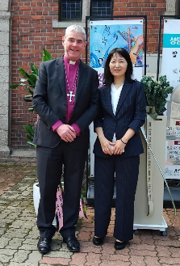
Dear Friends
Last month I was privileged to visit our link Church in Korea for the consecration of a new Bishop of Seoul, Bishop Elijah. His predecessor, Bishop Peter, had attended Bishop Debbie's welcome service in Peterborough earlier this year.

Our link relationship is in good heart. Since all the Korean bishops and their wives visited Northampton and Kettering a few years ago, we have welcomed students to camp at the Greenbelt Festival, provided a six-week placement for an ordinand and established three parish to parish partnerships. One of our clergy took a sabbatical at the Anglican university in Seoul.

I was made very welcome, joined worship in the now completed new Cathedral in Daejeon (it was a hard hat building site on my last visit!), and visited all three dioceses, including the port/resort city of Busan.

The consecration service which is available to view online was graced by four Archbishops, but our hosts kept talking about their connection with Peterborough and it was moving to realise how precious our relationship is to them.

In his inaugural address Bishop Elijah spoke humbly of the Bishop's calling to be a servant, helping the whole Church to flourish. He concluded; "When the Church is faithful to its identity, God will use it, no matter the challenges of the time. Let us strive to be a Church that reflects the Kingdom of God, serving with love and dedication."

With my prayers and best wishes,

Bishop John Holbrook
Bishop of Brixworth

Diocese of Peterborough - Magazine Resource - November 2024
Produced by the Diocesan Office, The Palace, Peterborough, PE1 1YB
Tel: 01733 887000 Email: communications@peterborough-diocese.org.uk
www.peterborough-diocese.org.uk

