The Christingle Service

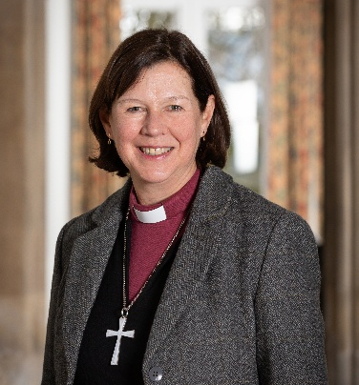
I wonder how many oranges will be used in our churches and schools this year as we celebrate a Christingle Service. For me, the lighting of the candle and the singing of ‘Away in a Manger’ has always been one of the most profound moments of the Christmas season. To watch young children (and adults, too!), be stilled in the gentle candlelight and to sing gently of the birth of Jesus, is a powerful way to recapture the joy and wonder of Christmas.
The Christingle itself is a sign of God’s love for the world, it is a promise of hope at times of darkness, it is a message that Jesus is indeed the light of the world. As each candle is lit, we can see how each one joins together to banish the darkness. This is our calling – to live lives that burn brightly with the love of Jesus and to work together to bring hope.
My prayer for you, is that you will know the light of Jesus in your own lives this Christmas and that you will experience that joy that comes from welcoming the Son of God into our lives.


The Rt Revd Debbie Sellin
Bishop of Peterborough

Diocese of Peterborough - Magazine Resource - December 2025
Produced by the Diocesan Office, The Palace, Peterborough, PE1 1YB
Tel: 01733 887000 Email: communications@peterborough-diocese.org.uk
www.peterborough-diocese.org.uk

