Lent 2026 – ‘Draw Near’

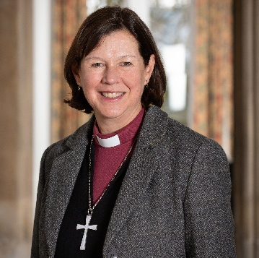
Lent is traditionally a time when Christians take time to reflect what it means to be a follower of Jesus and to prepare for the celebrations of Easter. This year, the Church of England has produced some materials under the heading, ‘Draw Near’, to help us develop some life-giving habits that will help us in our daily lives to draw nearer to Jesus.
Throughout the bible we read of people who encounter Jesus in amazing ways and whose lives are transformed. Often the story ends there, but of course, that is just the start of the journey. As followers of Jesus, we know that the journey continues as we build on our relationship with and understanding of God. Central to the journey lie certain habits that can help us: worshipping together, praying, reading and exploring the bible, sharing communion, offering service to those around us, and sharing the good news we have come to discover.
I wonder, this Lent, what you might focus on to deepen your own discipleship and nurture your spiritual life. As we draw near to God, he draws near to us and we can know his presence with us more fully. As Richard of Chichester prayed: ‘may we know thee more clearly, love thee more dearly, and follow thee more nearly, day by day.’



The Rt Revd Debbie Sellin
Bishop of Peterborough

Information on Draw Near and related resources can be found here https://tinyurl.com/2v49arbb or by scanning the QR code.

Diocese of Peterborough - Magazine Resource – March 2026
Produced by the Diocesan Office, The Palace, Peterborough, PE1 1YB
Tel: 01733 887000
Email: communications@peterborough-diocese.org.uk
www.peterborough-diocese.org.uk

