The Season of Lent

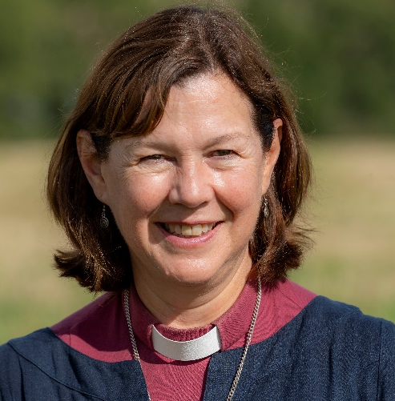
The season of Lent is a time when we can acknowledge the pain and hurt that we encounter in the world around us on a daily basis, to recognise the times of difficulty and uncertainty and to find Jesus in those dark places, as we remember his own struggles and temptations in the desert. Our world is broken in so many ways and we can often feel helpless and full of despair. Sitting with that pain is not comfortable and yet when we do so, we can encounter healing and hope.
This year’s Archbishops Lent book has offered resources drawn from Black Spirituality to help us find new wisdom even in times of struggle and trial. And this discipline of travelling with Jesus through Lent and the events of Holy Week both prepare us and give us fresh insight into the glory of the resurrection. As we wake on Easter Sunday, we can rejoice again that Christ is risen indeed – hallelujah.
I am delighted to now be ministering among you and I look forward to hearing your stories and getting to know you. I hope I will be able to meet you in person in due course and I am excited to hear about the hope of the risen Christ in your communities. The joy of Easter brings confidence in our belief that God does transform our hearts and lives and that his kingdom stretches to every corner. I pray that over the coming weeks and months, we all have new stories to tell of Christ at work in the lives of those around us.

+Debbie
Bishop of Peterborough

Diocese of Peterborough - Magazine Resource - March 2024
Produced by the Diocesan Office, The Palace, Peterborough, PE1 1YB
Tel: 01733 887000 Email: communications@peterborough-diocese.org.uk
www.peterborough-diocese.org.uk

