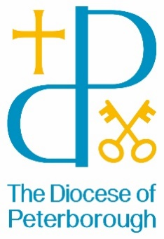

Insert parish name/logo here & office contact details

Media Consent Form
In celebrating, remembering and telling the stories of our churches, schools and associated groups and events, it is invaluable to use:
- photos,  - video and  - audio | in our | - print publications,  - website and  - social media | and sometimes those of | our related organisations:  - local church/school,  - Peterborough Cathedral,  - the national Church of England or  - local and national media.

We ask for your agreement that you/your child’s image/voice may be featured while participating in activities organised by the Diocese of Peterborough, our Parishes, Schools, and other associated organisations.
Date and description of event being photographed:
……………………………………………………………………………………………………………
……………………………………………………………………………………………………………
……………………………………………………………………………………………………………
Conditions of use:
- We may include details such as names or affiliated organisation when context requires it.
- We will always follow Diocese of Peterborough guidelines and policies relating to Safeguarding and Social Media, available at https://www.peterborough-diocese.org.uk/aboutus/safeguarding
- We may share photos/video within our Diocese, with Parish churches, Peterborough Cathedral, the national Church of England and local/national media. Please be aware that websites and social media can be seen throughout the world and not just in the United Kingdom, where UK law applies.

I have read, understood and agree to the Conditions of Use.
Name in block capitals:........................................................................................................
Signature (if aged 13 or over) Date:
…………………………………………………………………………… ………………………….
Signature of parent/guardian (if aged 16 or under) Date:
…………………………………………………………………………… ………………………….
Email (or address) Date of Birth (if aged 16 or under)
…………………………………………………………………………… ………………………….

Please return this form to the event organiser or photographer or email to communications@peterborough-diocese.org.uk

