**Mary visited by the Angel Gabriel**

In the story Mary was amazed at the news that she was going to have a baby, God’s own Son, and the angel said ‘Is anything too wonderful for God’

What do you hope and dream for in your life…for your family, your friends, for the world?

Some of them might seem to be ‘too wonderful’ to ever imagine happening, even impossible! Is anything too wonderful for God?

Write or draw your hopes and dreams onto a Post-It and put it in your box

**The Shepherds hear about Jesus**

In the time of Jesus people used to laugh at shepherds and say they were smelly and call them other rude names. You see, people thought shepherds were nobodies. But God must have thought shepherds were very important indeed because they’re the ones he chose to tell the good news to first.’

 Squeeze some plasticene and think about the

stress and hardness of life for people who

are thought of as nobodies in the world

today. Chat to God about your thoughts and

then put the plasticene in your box.

**No Room at the Inn**

Jesus had to be born in a stable, the only place they could find room. ‘Go away!’ the innkeepers told them. ‘There isn’t any place for you’.

Sometimes we can feel disappointed when people say words that seem unkind or mean, or they do unkind things to us.

And sometimes we can say or do unkind things to others.

Write or draw about the things you have said or done that have been unkind or made God sad. Now wipe it all away and think about how it feels to now see a clean slate- God promises to forgive and forget what we did when we say sorry to him.

Put the slate in your box so you can say sorry to God at home and wipe it clean

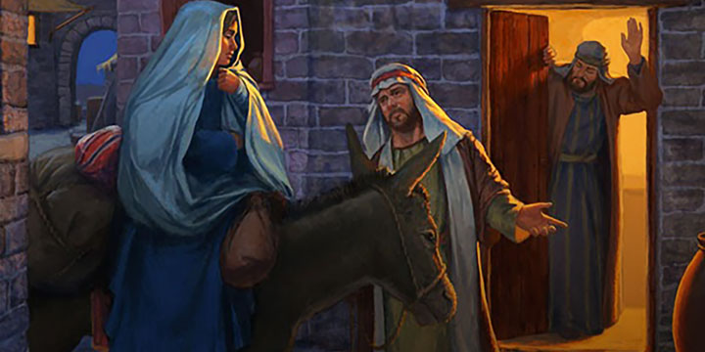

**Jesus placed in a Manger**

A manger was the feeding bowl for animals- hay was placed there for them to eat and get energy to live.

Take a piece of hay and hold it.

Think about what you would like God to give you to live well- maybe strength and energy, maybe food and warmth, maybe peace and love.

God promises to provide for all our needs so ask him now to meet your needs.

Put the hay in your box to remember to ask God to meet your needs every day.

**Gifts for a King**

The Wise Men bought three gifts to Jesus- gold, frankincense, and myrrh.

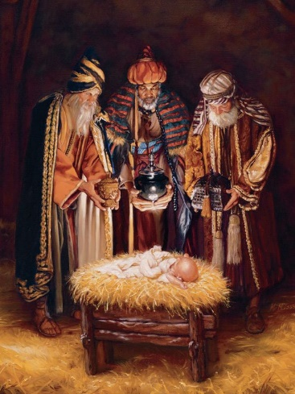Gold is a gift fit for a king and Jesus was the King of the World but he was born on earth so we could know Him as our King.

**Hold a gold coin in your hand and think about how special gold is. As you enjoy eating your gold coin remember God thinks you are very special-more precious even than gold.**

**Put the gold foil in your box to remind you at home how precious you are to God.**