And they were great!

God made mice!

Mouse facts:

1. A mouse is a small rodent with a pointed nose, long tail and round, furry body.
2. Mice are known for their high breeding rate and can be found almost everywhere in the world.
3. Mice eat between 15 and 20 times a day.
4. Mice can reach up to two years in captivity, but don't usually live longer than five months outside, as they are easily eaten by predators.
5. Female mice can start giving birth when they are just two months old and a female mouse can give birth to 150 mice in a year!
6. Even if they can live in any conditions, mice usually dig burrows underground to hide from predators.
7. They are [omnivores](https://www.twinkl.co.uk/homework-help/science-homework-help/carnivores-herbivores-and-omnivores/what-is-an-omnivore), which means they eat both plants and meat - usually whatever they can find!
8. Mouse urine has a fluorescent glow that can be seen by using a black light.
9. Although mice are best known for their love of cheese, this is actually more fiction than fact. They have a strong sense of smell and they aren’t attracted to many types of cheese that give off a strong odour. They much [prefer to eat grains, seeds, and even rotting fruits and vegetables](https://www.earthkind.com/blog/7-things-mice-love-most/) over cheese.
10. Mice can jump up to 46cms in the air, which given the size of a mouse, is an impressive leap for their little bodies. [Mice are quite the acrobats](https://www.earthkind.com/blog/can-mice-climb-exactly-can-fit-go/)as well; they are very efficient at swimming and climbing.
11. The saying ‘as quiet as a mouse’ is misleading, as they can make plenty of noise, especially at night! They use their claws to dig for food, find water, and nesting materials. Also, male mice “sing” when trying to attract a mate!
12. Though [mice aren’t necessarily nocturnal](https://www.earthkind.com/blog/mice-sleeping-habits/), they are typically the most active at night because this is when the least amount of danger is present. They sleep in a nest and typically leave to go look for food when the sun goes down, as this is typically when fewer people and predators are around.
13. Mice do have bones and their bones don’t collapse, however, they can fit through a tiny opening. Their skull is the biggest part of their body, so wherever their head can fit, they can go. This includes openings that are as small as a pencil.
14. Mouse footprints look like this:



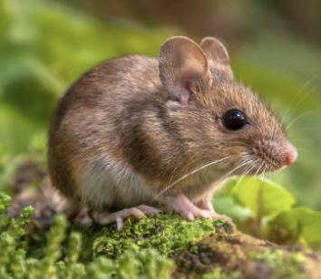

The mouse