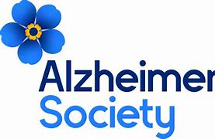**Peakirk cum Glinton Primary school**

We started the year with two boys in Year 6 who wanted to raise awareness of Alzheimer, due to having close members of their family experiencing this condition. With the help of their parents, Paul and Luke decided to make and sell a range of tie-dye items in the run up to Christmas. The idea being that by purchasing a small gift of a bag, t-shirt, pillowcase or hair scrunchy, the money raised would be given to Alzheimer’s society, UK. The boys spent time preparing a ppt to launch to the school, a notice in our school newsletter and then taking orders from parents using a form they had devised, as well as considering the best way to collect the money. They spent a week after school selling items on the playground, as well as preparing the orders in time for Christmas. It was a busy time for them and their families, but they successfully raised £206. We were very pleased and proud of their achievements which supported the current value of community which inspired them to do this in the first place.

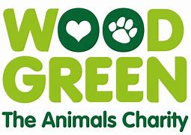

Three girls called Bethan, Edie and Darcey from Year 4 spent many lunchtimes collecting and wrapping up items for a lucky dip which they had shared information about in collective worship. They were able to sell items from 50p to £3 at breaktimes to both KS1 and KS2 children. They raised over £100 which went to Wood Green animal shelter and all of their lucky dips were sold out.

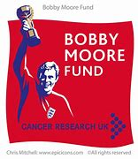

James and Kai also from Year 6 sold items to support the Bobby Moore foundation charity . One of the boys had lost a family member of bowel cancer so this charity was very close to their heart. Both boys are keen footballers and shared this passion for this charity when they spoke to the children in Collective Worship to tell them about what the Bobby Moore foundation means to them and how we can support this charity as a school. They sold some football-related mechanise after school on the final week of the Spring term on the front playground after school. They raised over £125.

Darlia in pre-school recently walked up the 3 Largest Peaks in the UK in under 30 days by a 3 Year Old!

⛰️ Snowdon - 1083m - 27th April 2024

⛰️ Scafell Pike - 978m - 11th May 2024

⛰️ Ben Nevis - 1345m - 26th May 2024

And raised over £1,700 for The Outward Bound Charity in the process!

We are beyond proud of her and what she has achieved.

Last weekend the conditions on Ben Nevis were fierce, once past 1000m she was faced with Ice, Snow, Hail, Rain and very strong winds. On the way down she encountered adults who had turned back before reaching the summit but Darlia pushed through showing her determination.

Thank you so much to all of you who donated to the mission and just know it will help inspire young people get outdoors and achieve more than they thought was possible. During her challenge it is fair to say Darlia truly embodies that spirit. Darlia even appeared on ITV news – Anglia news too!

A member of staff swam 44 miles in 3 months to raise money for Diabetes UK. Initially this was a challenge of 22 miles but she flew through that and managed to push on an raise over £300 and swim to to France and back (not in the English channel but at her local swimming pool!). This involved staff having a stake out for the Eurovision and the current Euros. Why this charity, again thinking closely about our own school community, we have a a pupil with type 1 diabetes who is an inspiration to us all in how she manages to stay positive everyday. Well done Ella!