Pentecost Kite

‘But you will receive power when the Holy Spirit comes on you; and you will be my witnesses in Jerusalem, and in all Judea and Samaria, and to the ends of the earth.’
Acts 1 v 8

To make a Pentecost Kite:
- Take a coloured piece of A4 paper
- Bring the two short sides of your piece of paper together and press along the bend to make a crease.
- Now is a great time to decorate your kite. Use pens, pencils, crayons, felt-tip pens, but be careful not to weigh it down too much. If it's too heavy it won't be able to fly!
- Bend the front corner of the top layer down to touch the crease, repeat on the back layer and staple. The essential thing with this step is to only bend the corners down. If you fold them the kite will not work. The exact position of the corner is not critical, but will affect how your kite flies. See diagrams below:
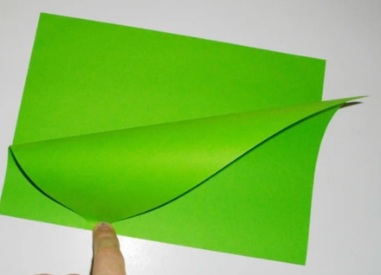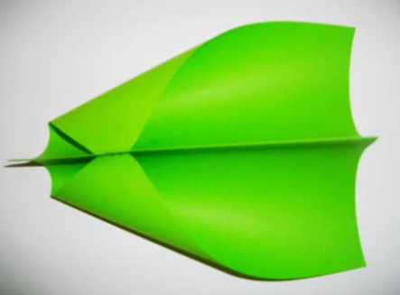

Make a hole near the front of the crease.

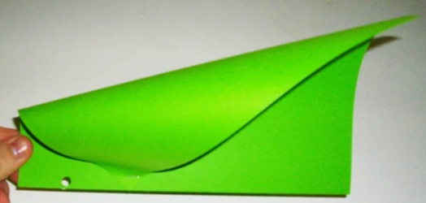

Thread string through hole and tie it off. If using loose string, you may like to tie it to a pencil, pen, stick or similarly shaped object and wind it around for ease of handling.

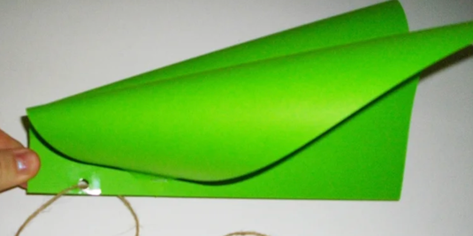

Have fun!!

