**Platinum Jubilee Resources**

As we start to plan for the long holiday weekend in June (Thursday 2nd – Sunday 5th June), here are some resources that will help celebrate the Queen’s Platinum Jubilee.

**From Hope Together:**

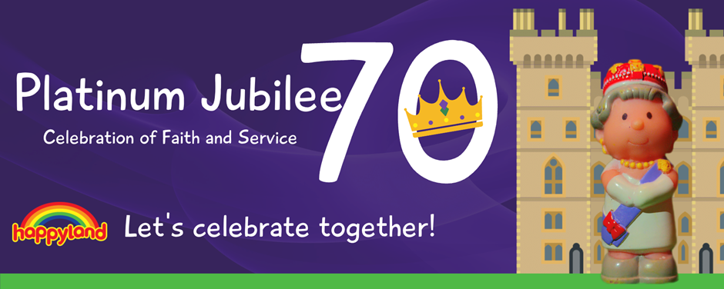

God’s Big Story is a set of well-known Bible stories made accessible and memorable for under 5’s and their families. Using Happyland toys from the Early Learning Centre, we tell each story through the lens of the big story of the Bible. Each storybook is available to buy and comes with free downloadable resources to support the experience. Children can hear, see, sing and play the story both at home and in a toddler group setting. Full details are available on our God’s Big Story resource page [Hope Together : God's Big Story Resources](https://www.hopetogether.org.uk/Groups/367949/Gods_Big_Story.aspx)

*‘The Girl Who Grew Up To Be Queen’* helps under-five’s to explore the Queen’s life and faith. Children and their families are introduced to Muick the Queen’s corgi who tells us all about his owner. With lots of guessing and dressing up opportunities we find out more about Queen Elizabeth and how we can all be princes and princesses, children of The King.

The book is available from the HOPE shop for £2 (£1 bulk) [www.hopetogether.org.uk/shop](http://www.hopetogether.org.uk/shop) and is supported by a free animated version of the story, a song by Pete James from The Cheeky Pandas complete with actions video, and toddler group resources provided by Anna Martin from Biblebuds. The resources can be found at [www.theplatinumjubilee.com/learn](http://www.theplatinumjubilee.com/learn)

For young people there are a whole host of resources on the website [www.theplatinumjubilee.com/learn](http://www.theplatinumjubilee.com/learn) suitable for both school and church contexts; assemblies, courses and session plans linked to the theme of faithful service. For young people and adults, we have produced the book*, ‘Our Faithful Queen’* exploring the Queen’s life and faith. It is also available from the HOPE shop for £1 (bulk).

**A whole suite of resources put together by HOPE and their many partners at** [**www.theplatinumjubilee.com**](http://www.theplatinumjubilee.com)

**From Muddy Church: Wonderful creative resources**

*This Muddy Church collection offers the opportunity to pause and take action through walking around our neighbourhood and to reflect. There are four parts that take a royal theme to help you engage in the spaces, places and things around you. These are connected through fun facts, wondering pages and ideas for activities that you can do*. [Jubilee (muddychurch.co.uk)](https://www.muddychurch.co.uk/_files/ugd/921837_3ccc0935bc0d4bf99bceb42b1209a204.pdf)

