God made rabbits!

And they were good!

Rabbit facts:

1. Wild Rabbits have greyish-brown fur with a characteristic white flash on the underside of their tail. Their long ears! Growing up to 10 centimetres in length, rabbits can turn their ears by 180 degrees, keeping a careful listen out for predators.
2. Adult rabbits weigh around 1.2 to 2 kilograms. They can be 30-40 cm long, making them smaller than most domestic rabbits
3. The average lifespan of a rabbit is 3 years but they can live for up to 9 years.
4. They live in large groups in underground burrow systems known as ‘warrens’.
5. A baby rabbit is called a kit, a female is called a doe and a male is called a buck.
6. A rabbit’s teeth never stop growing! Instead, they’re gradually worn down as the rabbit chews on grasses, wildflowers and vegetables — meaning they never get too long.
7. Rabbits are very effective baby-makers! Mother rabbits are pregnant for between 28-31 days, giving birth to up to 14 baby rabbits – called kittens – in a single litter. There are over 45 million rabbits in the UK alone!
8. The rabbit is native to Spain and was introduced to this country by the Normans in the 12th century to provide food and fur.
9. Rabbits are naturally social animals and companionship is important to them. In the wild, rabbits live in family groups which can reach up to 30 in one warren!
10. Rabbits perform an athletic leap, known as a ‘binky‘, when they’re happy — performing twists and kicks in mid-air! They can jump as high as 90 centimetres in one leap!
11. Like cats, happy rabbits purr when they’re content and relaxed
12. In the UK, rabbits are a food source by many birds of prey including buzzards and goshawks. Foxes and badgers frequently also hunt them.
13. In general, rabbits will actively play in the morning and evening by chewing, digging, and foraging. In the middle of the afternoon and at night, rabbits will settle down and sleep for a combined total of 12 hours in a day.
14. Carrots aren’t a natural part of a rabbit’s diet and can give bunnies an upset stomach if they eat too many.
15. Rabbit tracks look like this:



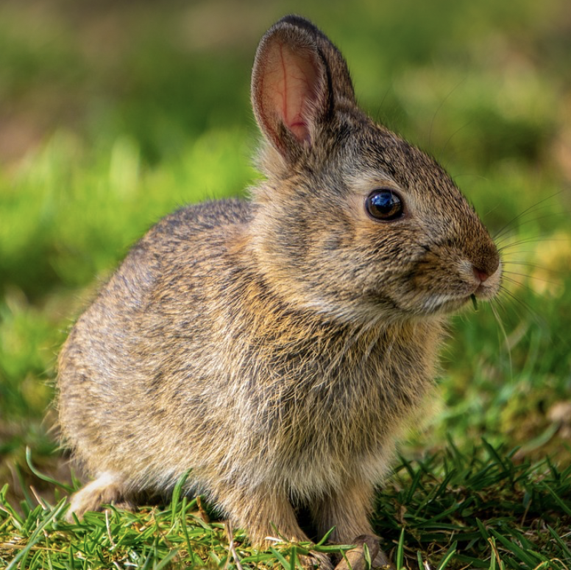

The rabbit