And they were great!

God made squirrels!

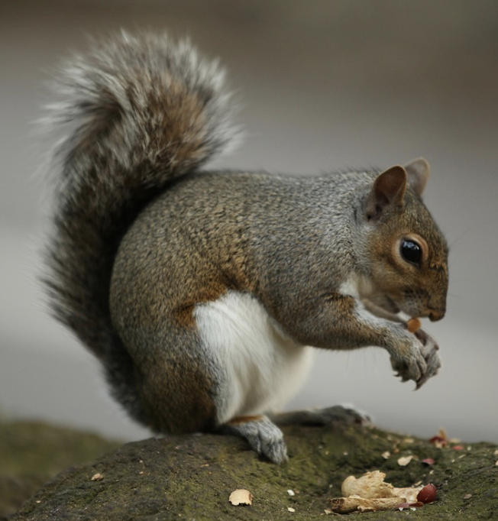

Squirrel facts:

1. Grey squirrels were first introduced to England from North America in 1876 as an ornamental species to populate the grounds of stately homes. Grey squirrels have rapidly spread and colonised much of mainland England with detriment to our wildlife, especially the native red squirrel. Squirrels are rodents.
2. Grey squirrels predominantly seek out high-calorie seeds such as acorns, beech nuts, hazelnuts, sweet chestnuts and walnuts. Squirrels will also dine on flowers, fungi, shoots and some plant bulbs, as well as sometimes turning to insects, such as caterpillars and bird eggs.
3. Squirrels are solitary animals and spend most of their time on their own. They also nest on their own. However, when their mating season begins, they couple up and lives in one nest. They also do so when the winter months get very cold.
4. Whilst Grey squirrels are mostly grey, some are black and occasionally white.
5. Squirrels are born blind and are about 2.5cm long
6. Grey squirrels are masters at finding their buried nuts. Thanks to their wonderful sense of smell, they usually recover around 80 percent of all the nuts they bury!
7. When squirrels feel threatened, they run away in a zigzag pattern. This is an incredibly useful strategy to escape hawks and other predators.
8. They can be right- or left-handed! They have four fingers and five toes.
9. They can swim. They can hang upside down.
10. Squirrels don't hibernate. Squirrels' nests are called ‘dreys’.
11. Squirrels may pretend to bury a nut to throw off potential thieves. Squirrels have been observed engaging in “[deceptive caching](https://www.nwf.org/en/Magazines/National-Wildlife/2008/Science-Sleuths-How-Squirrels-Hide-Nuts).” This is where a squirrel digs a hole and vigorously covers it up again, but without depositing the nut. It seems this is done to throw off potential food thieves.
12. A squirrel's tail helps them with balance but can also be used for communication. If a squirrel sharply flicks its tail, this could be a signal of aggression or agitation directed at other squirrels and is sometimes accompanied by vocalisations. Or it could show a predator that's it's been spotted.
13. The main predators of grey squirrels include stoats, goshawks and foxes.
14. The average lifespan is approximately 9 years
15. Squirrel tracks look like this:

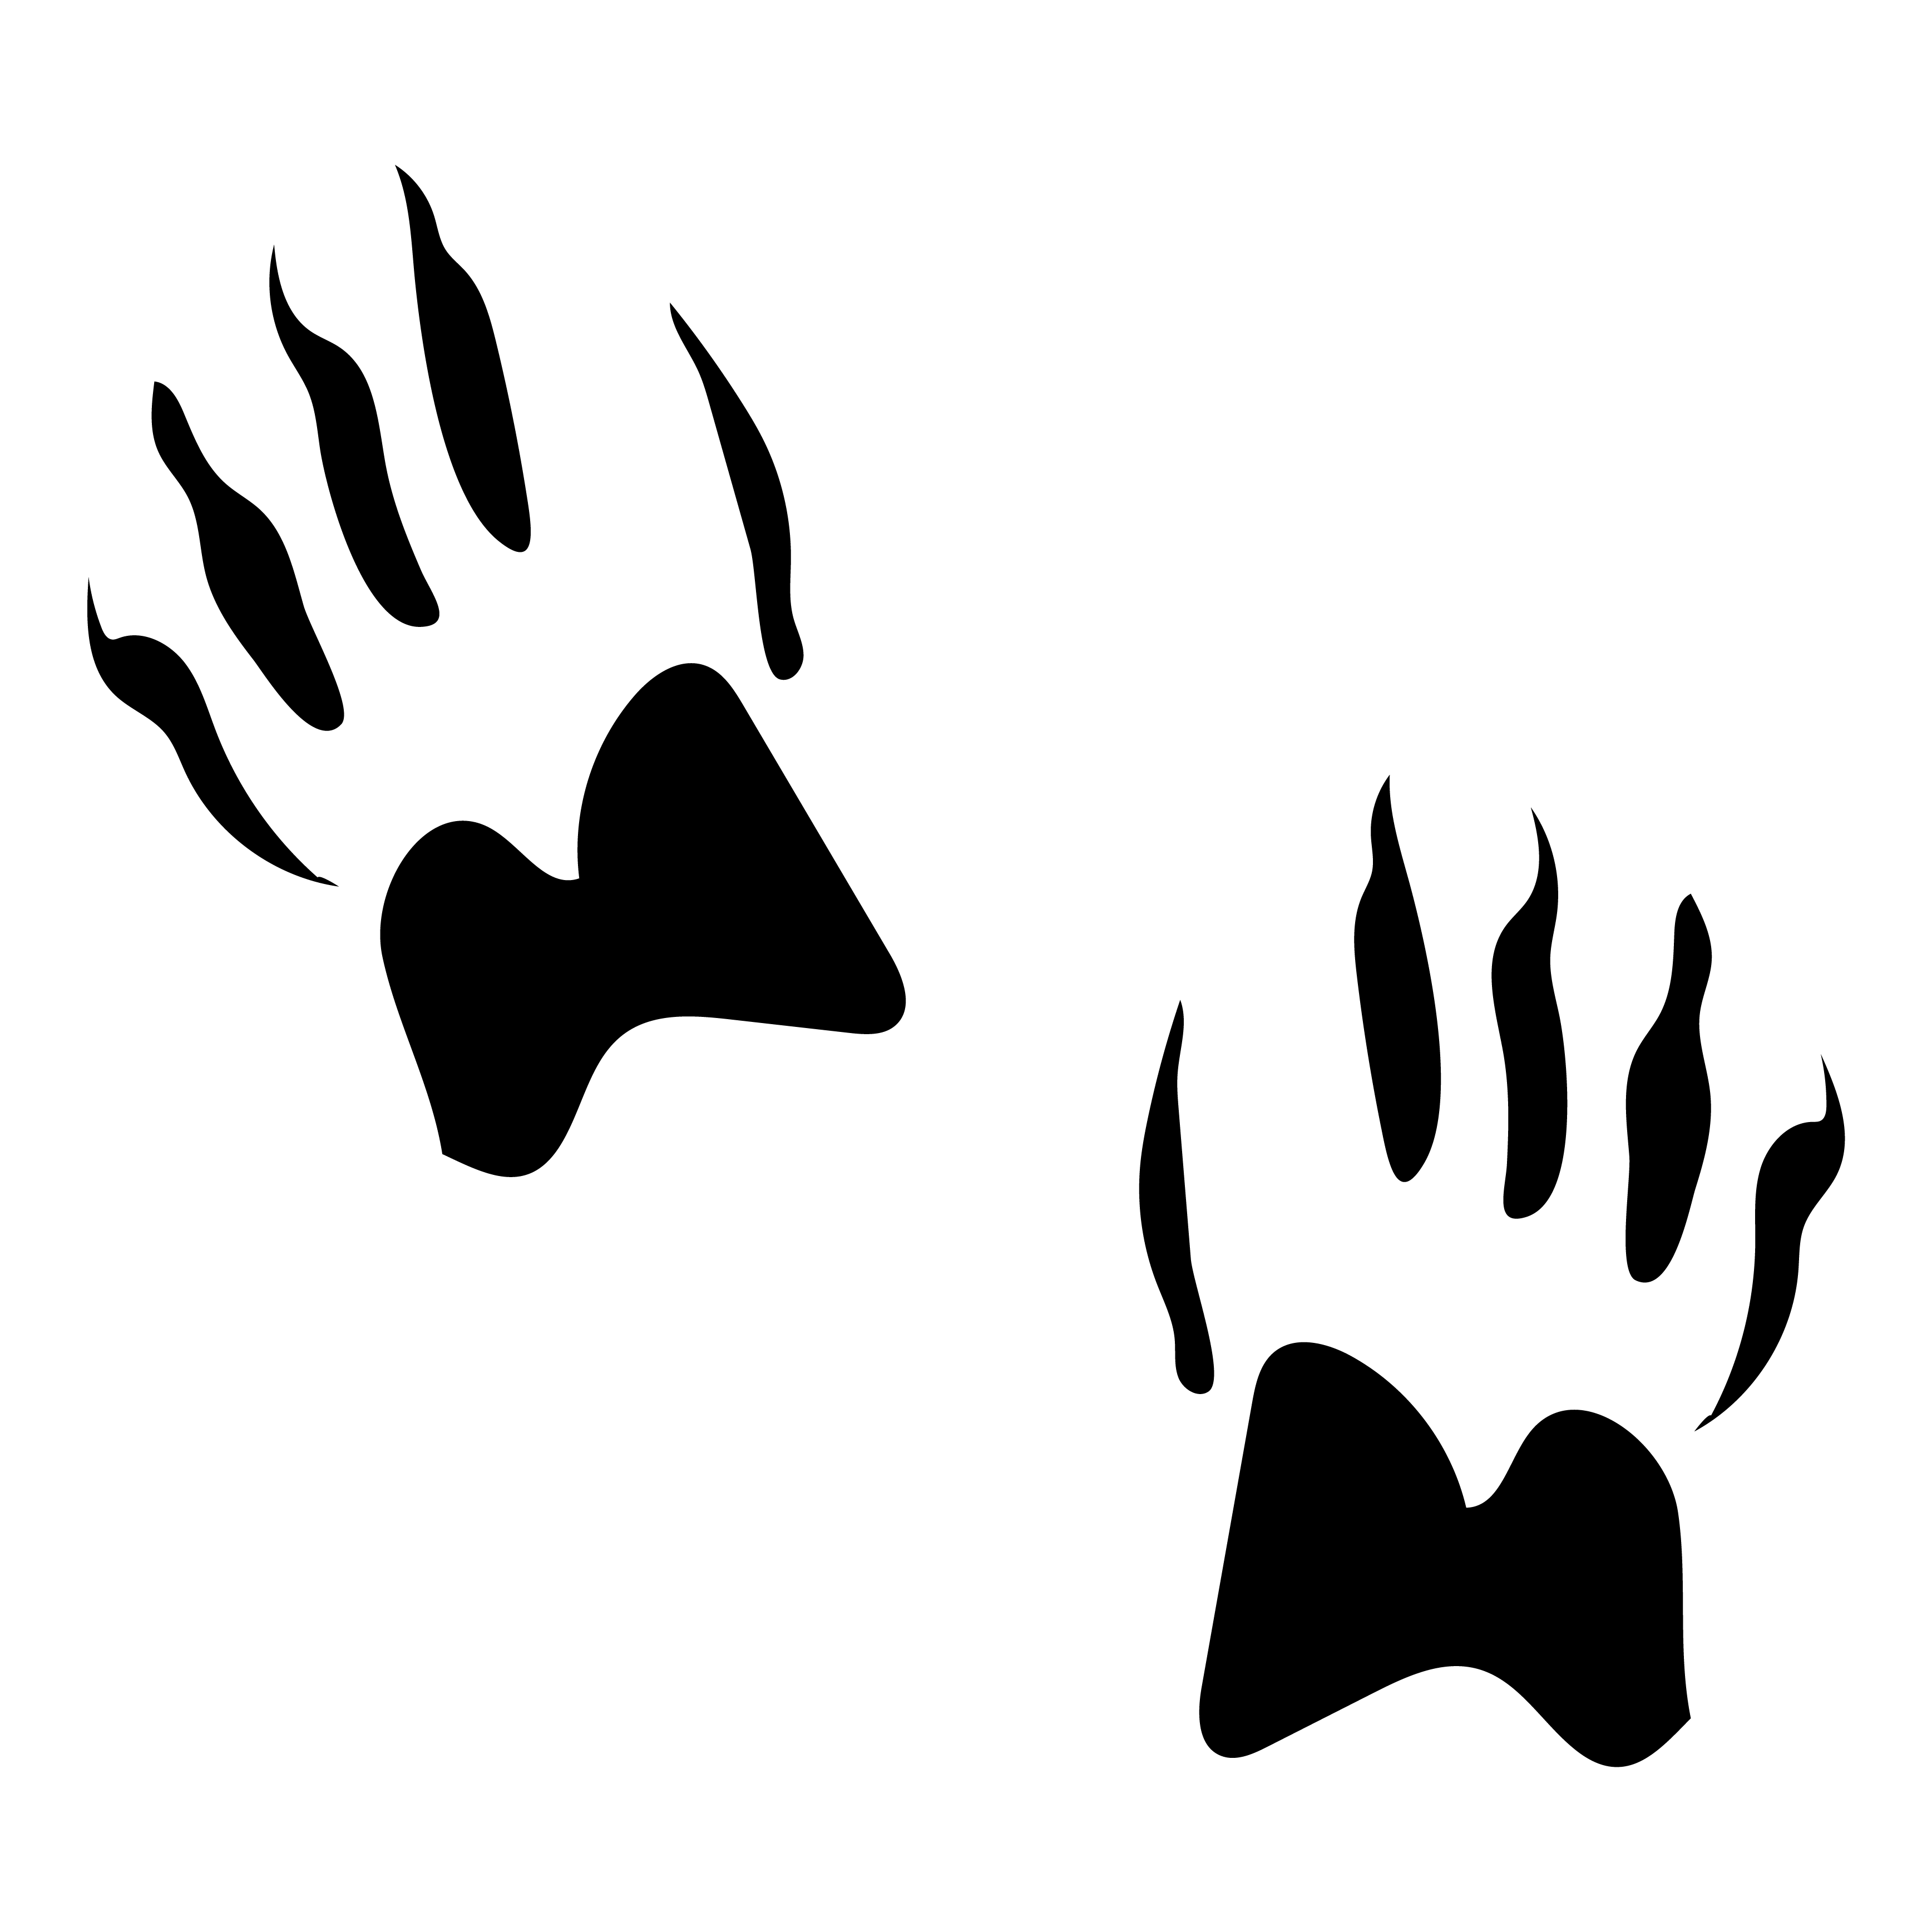

The squirrel