Celebrating
Holy Communion

All about me . . . .

My birthday is

I live at

My favourite food is . . . My favourite colour is . . .

What makes me happy: What makes me sad:

I belong . . . in a family

Who is in your family?

I came into this family on

What do you want for your family? Write a prayer

I belong . . . in this school
My My

My teacher is

My friends include

At school we

I am good at

I am not so good at
I belong . . . . in church
My My

I belong to the church near school. It is dedicated to which saint?
I also belong to the church where I live. It is dedicated to which saint?

And the priest is called
In church we

God loves me!

God knows me by my name.

God knows my family by their names.

God knows all the people in my school by their names.

God knows all the people in my Church by their names.

God knows all the people preparing to receive Communion by name.
Names
Names are a special sign of belonging.
My family’s name is:
My best friend’s family name is:
Here are the jumbled up names of some of Jesus’ disciples. Can you work out who they are? Write them underneath.
treep nohj smeaj
nomis hippil

Do you know of any other disciples?

Can you name some inspiring Christian people who have lived more recently?

Signs of belonging

Badges are a sign of
belonging - Cubs, Brownies,
football clubs.
Draw a badge

In church, the sign
of the cross is used.
When?

How many different
types of cross can
you draw?

What is baptism?
How do people join a family? . . a school? . . a church?

What happens in a baptism service?
Thanking God Making promises
Listening to God’s word, the Bible
Affirming beliefs Following Jesus’ command
Starting on a journey Travelling this with others
Praying for God’s help Being sent out

What symbols are used?

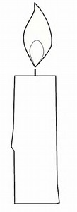

Celebrating
We celebrate different things in different places. Can you link up these celebrations with a place (some things can be celebrated in more than one place, so use 2 or 3 lines)
Christmas  Wedding  Leaving school  Mothering Sunday  Christingle  End of term  Holy Communion  New baby  Anniversary |  | Birthdays  Baptism  New job  Eucharist  Passing exams  Carol service  Harvest  Retirement  Easter
Signs and symbols
Do you recognise these signs?

And what do these Christian signs and symbols represent?
“Do this remembrance of me”
Remembering is an important part of our lives.
Do you have things to help you remember at home, like a baby book or a photo album? Or other things?
In church we remember things too. Are there things in church that help us remember specific people and events?
In a Communion Service we follow Jesus’ command to remember the Last Supper Jesus had with his friends and the death of Jesus on the cross.
We use bread and wine as Jesus did:
He ………………… bread, he ………………. It,
he ……………….it and he …………………..shared it.

What else is important about Holy Communion?

How can we respond to God’s love for us?

Would you like to be baptised?

Would you like to receive communion?

This church and people at your parish church welcome people like you to learn more about Jesus with them. Adults can affirm their faith in Confirmation.

Talk to your family about this.

Talk to God about this – this is called prayer.

How do I pray?
Prayer is all about talking to God and listening to him. It’s how we communicate with God.

God knows our needs, but he likes us to bring them to him.

One way to do this is using the Lord’s Prayer, but there are many other ways to pray

You can: praise God  ask God  ACTS  Or just be with God | say sorry thank God  adoration/ confession/thanks/supplication  Or use your fingers:
Thumb – pray for all who protects and care
Index – pray for things to show us the way
Middle – pray for all the powerful people in the world
Ring – pray for relationships, the poor and vulnerable people
Little – pray for yourself

How do I live as a Christian?
How does God want us to live? What does God care about?
Where do we discover about these things? Who gives us a good example?
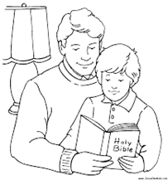 proclaim nurture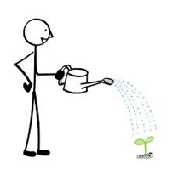
respond transform safeguard creation
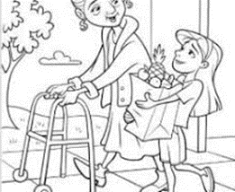

What help does God give us?

So many questions . . . . so much to do. . . .
being a Christian is the adventure of a lifetime!
Prayer of St Richard of Chichester
Thanks be to you,
my Lord Jesus Christ,
for all the benefits which you won for me,
for all the pains and insults which you bore for me.
O, most merciful Redeemer, Friend and Brother,
may I know you more clearly,
love you more dearly,
and follow you more nearly,
day by day. Amen.

You could use this space to write your own special prayer:

