**Archway Wildlife Quiz**

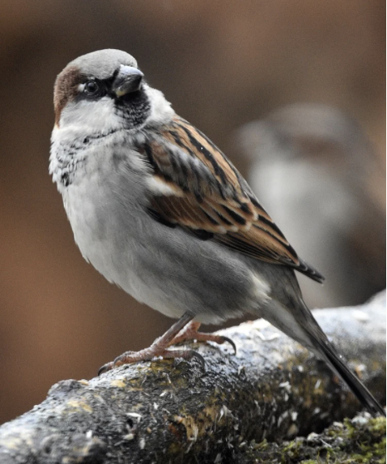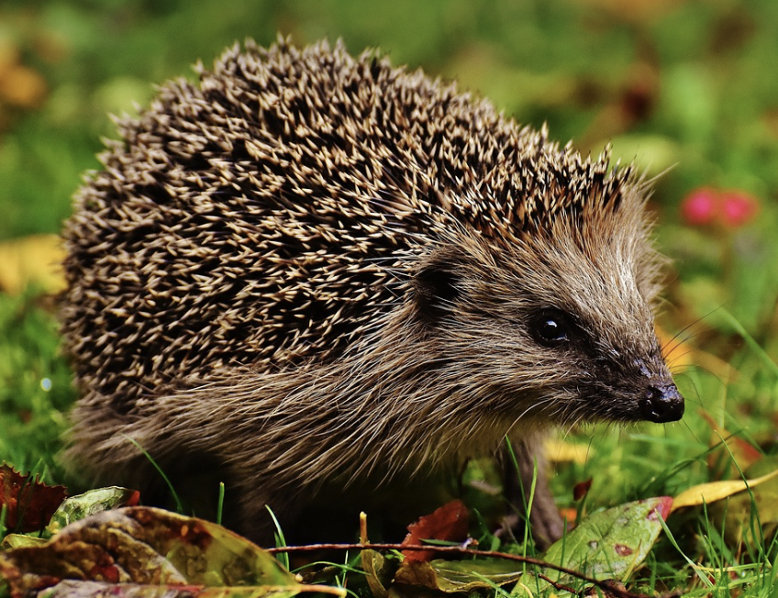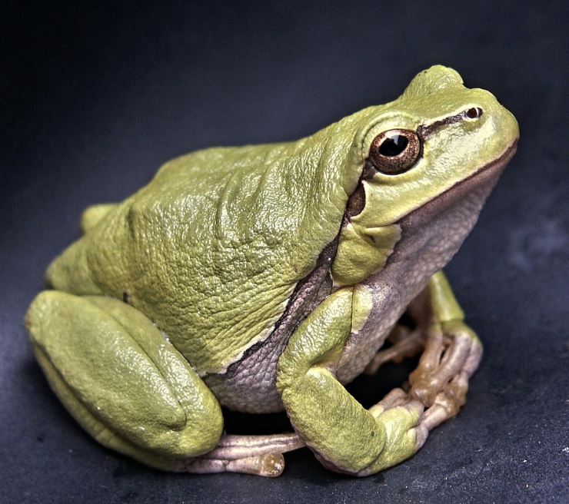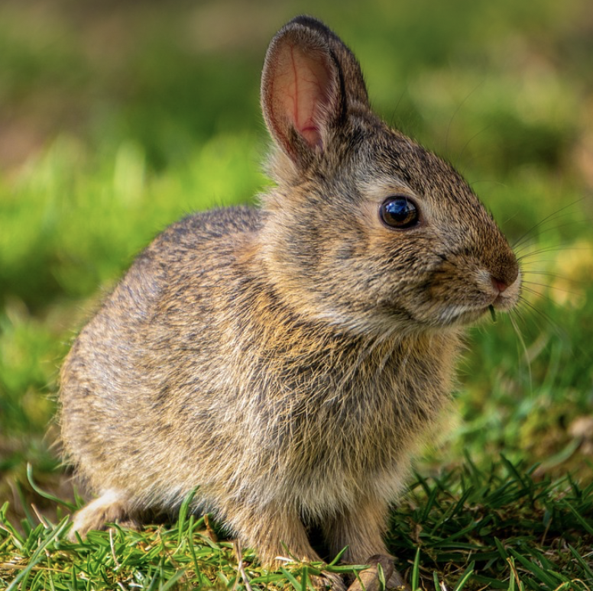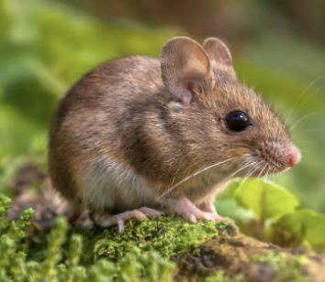

1. What is a group of frogs called? ___________________________________
2. What male animal sings to attract a female? _________________________
3. What baby animal is called a kit? __________________________________
4. What animal has a dust bath? _____________________________________
5. What animals were sent into space by NASA? ________________________
6. Which animal has fluorescent wee? ________________________________
7. Which animal can be right or left-handed? ___________________________
8. Which animal purrs when it is happy? _______________________________
9. Which animal’s front teeth never stop growing? _______________________
10. What is the top speed of a ladybird? ________________________________
11. Which animals dig burrows? _______________________________________
12. Which animals use ‘deceptive caching’? ______________________________
13. What is a family of hares called? ____________________________________
14. What strange part of their body to frogs use when eating? _______________
15. How fast does a bluetit fly? ________________________________________
16. What happens when a hedgehog runs? ______________________________
17. Where can you find caterpillars? ____________________________________
18. Which animal performs a ‘binky’? __________________________________
19. How high can hares jump? ________________________________________
20. Which animal has their eyes and nose on the top of their head? __________
21. Which colour can bees not see? ____________________________________
22. How fast can a hedgehog run? _____________________________________
23. How many different species of birds are there in the UK? ________________
24. Which animals can swim? _________________________________________
25. How many spines does a hedgehog have? ____________________________

