Candy Cane Olympics + Talk and Song idea

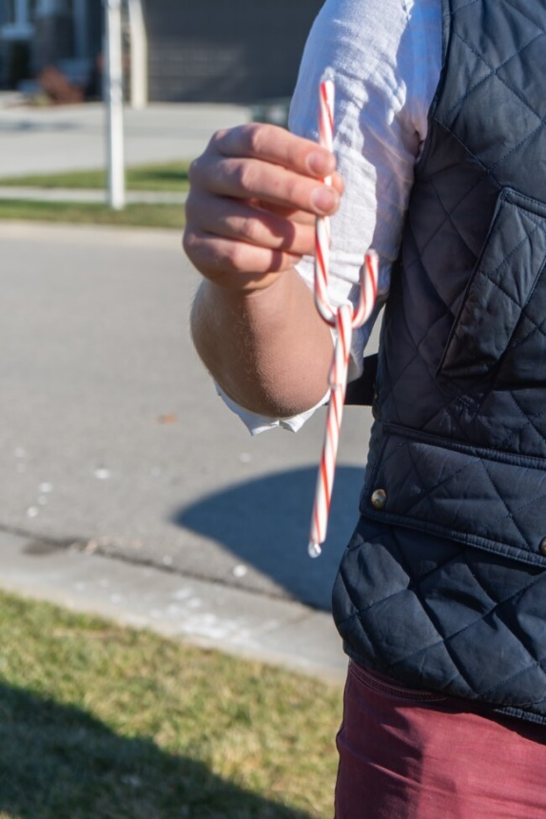
Game 1 – Candy Cane 4×1 Relay
Players: Each team needs 3 or 4 players
Supplies needed:
• One candy cane per teammate + one extra candy cane
• Tape (to mark the starting/finish line)
How to Play:
Have half of each team line up on one side of the room behind a taped starting line. Have the other half line up on the other side of the room. Give each player a candy cane and give the first person (Player 1) on each team a second candy cane. That person should hook the candy cane on the bottom of the candy cane they’re already holding.
When you say go, the first person should walk across the room to their teammates on the other side. When they get there, they need to transfer the hooked candy cane from their candy cane to the other person’s candy cane, without touching it with their other hand. That person then go to the other side again, transfers their candy cane to the next person. Continue until all teammates have completed their legs. Teams with four people will have each person walk one leg of the relay, teams with three people will have player 1 walk two (they’ll walk the final leg). That person then go to the other side again, transfers their candy cane to the next person.

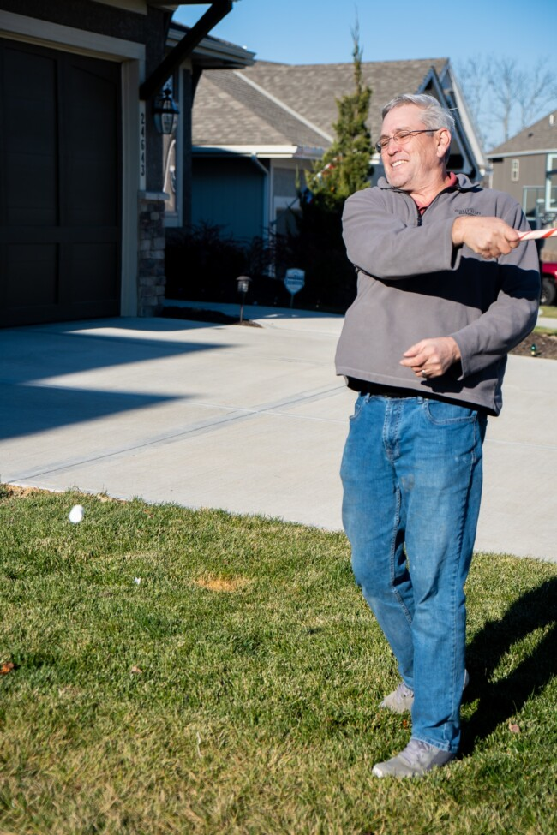
Game 2 – Caneball
Supplies needed:
• One candy cane stick (get a few extras in case one breaks)
• Regular size or jumbo marshmallows

How to Play:
Give each player three marshmallows and a candy cane stick
Players one at a time get three chances to toss up the marshmallow and hit it with their
candy cane stick. Keep track of where any marshmallow they hit lands.
Rotate to the next player and let them hit their marshmallows. Keep going until
everyone has had a chance to hit.
The longest hit marshmallow wins a point for their team!

Game 3 – Candy Cane Stringing
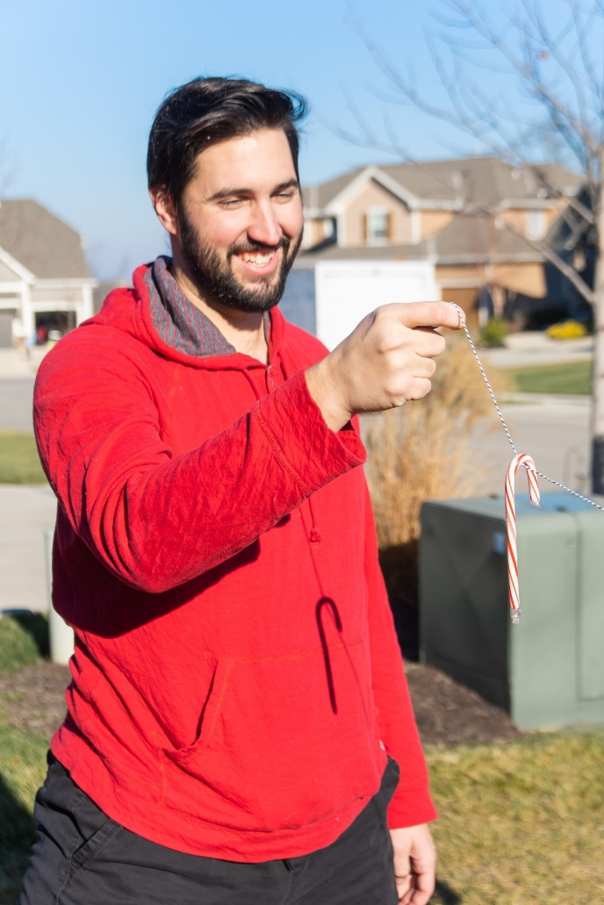
Supplies needed:
• One candy cane per team (have some extras on hand in case it breaks)
• One 14″ string/cord per team

How to Play:
Give each team a string and a candy cane. The two players on the team should take opposite ends of the string and walk to opposite sides of the room holding their end of the string.
When you say go, the person with the candy cane should hook the candy cane onto the string then try to transfer the candy cane to their teammate, hanging on the string. If the candy cane drops, they have to pick it up and start that portion of the process back (so if
you’re on the back half, you can just start with the second half)

Sounds easy right? Here’s the tough part – no moving anything other than your arm. So you can’t bend down, you can’t go up on your tiptoes, can’t crouch. No moving, nothing. Just move your arm up and down.

First team to get their candy cane to their teammate and back wins.

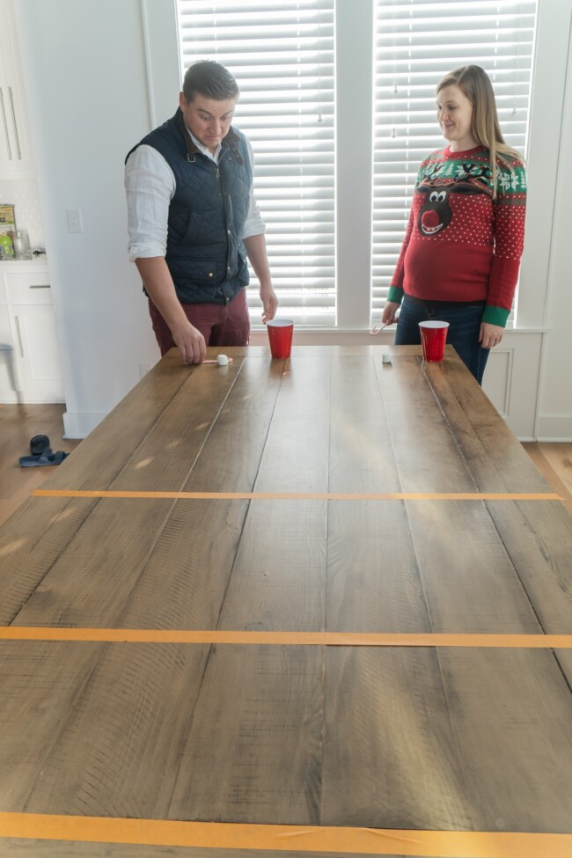
Game 4 – Candyboard

Supplies needed:
• One candy cane per player
• Five marshmallows per player – I recommend different colour marshmallows or marking the marshmallows in some way
• Masking tape
How to Play: Before your play, tape three lines of tape onto a table, spaced a little way apart and at least a little way away from the end of the table. These will be your scoring lines.

Give each player a candy cane and five marshmallows. To play, players take turns using the candy cane to push (or flick or whatever they want to do) a marshmallow down the table. If they land the marshmallow in the first taped off space, they earn 3 points in the game, if they land it in the second taped off space, they earn 5 points, and the final taped off space is 10 points. Take turns pushing marshmallows down the table.

At the end of the 5 marshmallows, count up the number of points for each of the marshmallows. Marshmallows only count if they are still on the table at the end of the round and if they are completely in the scoring sections, not touching the tape. The team that gets the most total points wins.

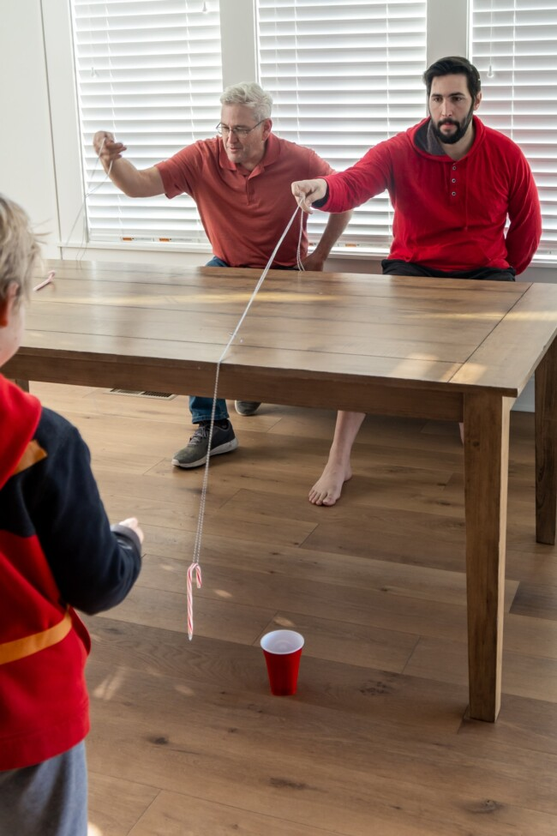
Game 5 – Candy Cane Abseiling

Supplies needed:
• One candy cane per teammate (plus extras in case they break)
• One plastic cup per team
• String that’s long enough to reach from the end of a table, over the table, and into a
cup tied into a loop.

How to Play:
Have one player on each of the teams sitting at the edge of the table and one player
from the team standing on the other side of the table, a little bit back so they don’t get in
way of the canyoning.
Give each team a string and a candy cane. Put a plastic cup at the bottom edge of the
table on the opposite side of the players sitting. Make sure it’s placed in a spot that the
candy canes on the strings can actually get into it (not too far forward or back).
When you say go, players must hook the candy cane on their string and do whatever
they can (toss, slide, etc.) to get the candy cane from where they are to the inside of the
cup.
Rules:
- They cannot look under the table at any time to see the cup
- Year 6 must do this with one hand behind their back (so they can only use one hand)

Once the candy cane is over the edge of the table the second player on each team can
help call out directions to get the candy cane into the actual cup. This makes it a lot
more difficult (and funny) than if the first player simply looked under the table to direct
their candy cane.
First player to get the candy cane totally into their cup wins a point for their team
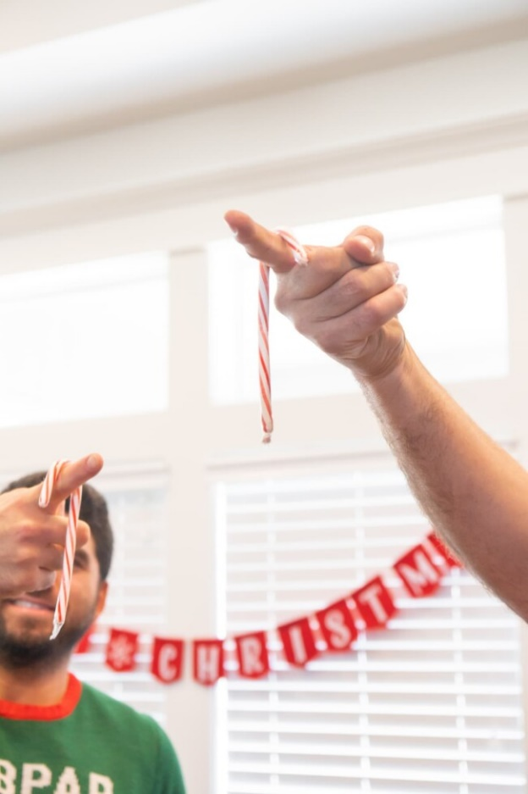
Game 6 - Candy Cane Catch

Supplies needed:
• One candy cane per team (plus extras in case candy canes break)

How to Play:
Have one player from each stand in a line side by side. Have their teammate stand
opposite them, about three feet apart. You don’t want much further or this will be
REALLY tough.
Give players on one side a candy cane.
When you say go, those players must toss the candy cane to their teammate who must attempt to catch the candy cane on one held out finger.
Any team who catches the candy cane scores a point for their team.
When you say go again, that teammate must toss it back to their teammate to catch on their finger.
Toss a total of six times (three per teammate) and whichever team catches it the most times wins.
If it’s a tie, do a sudden death round. Teams toss and catch and if they drop it, their team is out of the tiebreaker. Each round take a step back to make it more difficult (just for the tiebreaker, not the normal game). Last team standing wins.

Talk idea

- You can turn the candy cane round to look like a J and say that Jesus was the baby born at Christmas

- You can make the candy cane look like a Shepherds crook and talk about one aspect of the Shepherds story

- You could talk about the white bit of the candy cane and talk about Jesus being perfect

- You could then talk about the red bit and say that reminds of Jesus’ blood. That he came into the world to save it etc…

Song Idea

Christ the King of Christmas by Colin Buchanan.


Game 7 – Twirling Marathon

Supplies needed:
• One candy cane per teammate
How to Play:
Give everyone one regular size candy cane – ideally ones that have a little more space in their curved section than the super tight ones.
I recommend giving people a minute or two or practice this before you start the twirling marathon.
When you’re ready to start, count to three then say go. When you say go, everyone must start twirling the candy cane on one finger. As soon as someone either drops the candy cane or it stops spinning, they’re out.
Keep going until you everyone is out other than one person. That person is the winner.

