A season of transition

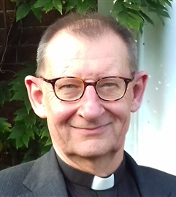
July is a season of transition.
For many of our young people it’s time for well-earned break after exams and the anxious wait for results – with all that can mean.
For others of us, it may be time for a holiday; or finding space to recharge our batteries.
For a few in our churches, those being ordained deacon or priest, it marks both an end and a beginning: the conclusion of a long period of preparation, study and formation; and then coming to terms with a new role, new expectations and new responsibilities.
Whatever July means for us personally, in the Church’s calendar it’s just a fragment of ordinary time; with none of the drama we associate with Christmas or Easter, of Pentecost, (just as of course, for many of us, July will not bring any respite from our regular routine).
Nevertheless, God is with us in the ordinary moments as well as in the times of crisis, he is with us in stability as well as in change. When we rest, he is the still point of the turning world, when in times of change or trial he sustains and upholds us.
As the psalmist puts it: ‘If I take to the wings of the morning and settle in the farthest limits of the sea, even there your hand shall lead me and your right hand shall hold me fast.’ (Psalm 139: 9-10)
Whatever July means for you, may you find Christ’s peace at the heart of it all.
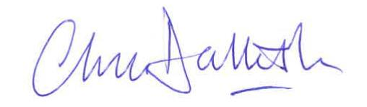

The Very Revd Chris Dalliston
Dean of Peterborough

Diocese of Peterborough - Magazine Resource – July 2026
Produced by the Diocesan Office, The Palace, Peterborough, PE1 1YB
Tel: 01733 887000 Email: communications@peterborough-diocese.org.uk
www.peterborough-diocese.org.uk

