Change and transformation
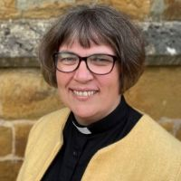
August is a time when the Church thinks about change and transformation. It is ‘ordinary time’, which is that time of the year when we’re not preparing for, or celebrating, either of the major festivals of Christmas or Easter but we are thinking about growth and creation.
It is also the month when the Church remembers the story of the Transfiguration. Jesus on the Mountain is changed (transfigured) in front of his amazed disciples. This story of life, light and connection with heaven comes as Jesus prepares for his death. He leaves the mountain and goes down towards Jerusalem and the events of that first Holy Week.
At this time of year, I am often thinking of children preparing to return to school, or even more poignantly begin new schools; we see a change in them.
As the summer draws to a close we prepare for autumn and a very different sort of season. The growing also draws to a close, the seeds are prepared and the sense of death that will lead to life is there for us to see if we want to.
An old chapter is closing and a new one beginning for many. Life is created by just such occasions; whether we are enjoying the wonder of creation, finishing with one experience, looking forward to a new one, enjoying the sunshine and the life of summer or glimpsing the beginning of autumn, I pray that you will know the transformation of God’s presence.

The Venerable Alison Booker
Archdeacon of Oakham

Diocese of Peterborough - Magazine Resource – August 2026
Produced by the Diocesan Office, The Palace, Peterborough, PE1 1YB
Tel: 01733 887000 Email: communications@peterborough-diocese.org.uk
www.peterborough-diocese.org.uk

